**8年级（上）英语第6课时（第2周）**

**《心之所至，即为故乡》学习指南**

**【学习目标】**

1.能够运用所学短语，如：in the east of /in the northeast of…, have a population of, be famous for等描述自己的家乡。

2.能够读懂有关剑桥、伦敦以及家乡的文章，并获取文章的主旨大意和细节信息。

3.能够通过阅读有关家乡的文章，梳理描写家乡文章的框架，并能运用所学内容口头描述自己的家乡。

**【学习任务】**

任务1：你了解你自己的家乡吗？请写出一两句英文尝试描述一下你的家乡。

___________________________________________________________________________________________

任务2：观看“学习指导”视频中对方位的讲解，总结写出描述方位的短语。并在下面地图中找到自己的家乡，尝试着写下你的家乡的地理位置。

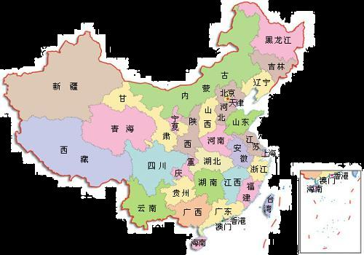

______________________________________________________________________________________________________________________________________________________________________________________

任务3：请翻到教材第12页Module 2 Unit 2，阅读文章的前两段，并跟着“学习指导”视频，完成下面的阅读任务。

1. Read the passage and answer the question.

What does Tony Smith mainly talk about?

__________________________________

1. Read paragraph 1 and find some information.

1) Where is Cambridge? _____________________________________________________.

2) What is the population of Cambridge? _________________________________________.

3) What is Tony’s home town famous for? ________________________________________.

4) What can we do if we visit Cambridge? ________________________________________.

3. Read paragraph 2 and complete the table.

|  |  |
| --- | --- |
|  | London |
| Location |  |
| Population |  |
| Famous places |  |
| River |  |

4. Answer the question.

Which city has a larger population, Cambridge or London?

____________________________________________________.

任务4：阅读Li Hua’s home town, 并跟着“学习指导”视频，完成下面的阅读任务。

Read and check (√) the true sentences.

  I come from Hangzhou. It lies in the southeast of China and faces the East Sea. My home town has a population of more than 10 million. It is famous for its beautiful West Lake. There are lots of parks and some places of interest around the West Lake. During the holidays or festivals or at the weekends, people like boating on the water or walking on the paths of the woods or sitting on the ground to have a picnic. What a good time they have!

Great changes have taken place in this city. People in my hometown are hard-working. They are brave. They work hard to make my home town become richer and stronger. Welcome to my home town.

1. Li Hua’s home town is in the northeast of China. ( )

2. There are about 10 million people in her home town. ( )

3. Hangzhou is famous for the East Sea. ( )

4. During the holidays or festivals or at the weekends, people like boating on the West Lake. ( )

5. Li Hua’s home town is becoming richer and stronger. ( )

任务5：观看“学习指导”视频中的Summary: How to talk about home town，写下描述家乡的句子结构框架。

1.______________________________________

2.______________________________________

3.______________________________________

4.______________________________________

5.______________________________________

6.______________________________________

任务6：请你作为家乡的形象大使，根据任务5的提示内容，口头描述自己的家乡。

E.g. My home town is…a… city in the… of China. It has a population of…