**8年级（上）英语第12课时（第3周）**

**《让我们都“运动”起来吧！》学程拓展**

**奥运会的全称是“奥林匹克运动会”(**the Olympic Games)**,发源于2000多年前的古希腊，因举办地在奥林匹亚而得名，是目前世界上影响力最大的体育盛事。大家知道夏季奥运会比赛项目的英语表达方式吗？扫码学习一下吧！**

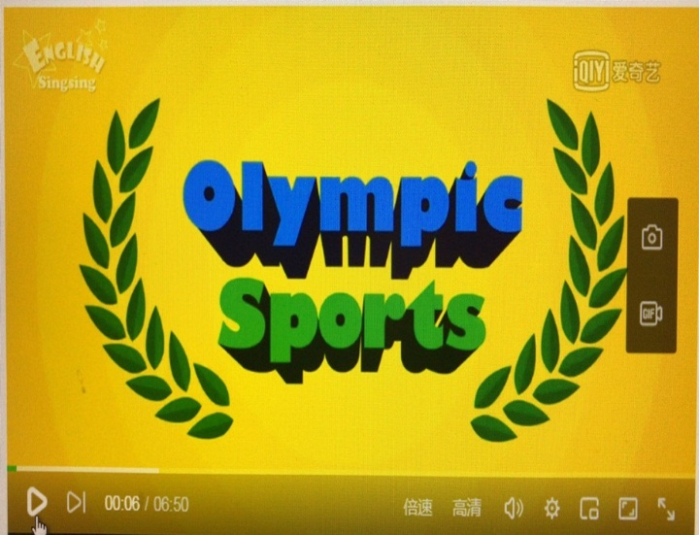 

**众所周知，运动有益健康。阅读下文，让我们从科学的视角来了解一下二者之间的联系吧。**

**Exercise and Health**

For thousands of years, physical activity has been associated with health. Today, science has confirmed（证实）their link, with overwhelming evidence that people who lead active lifestyles are less likely to die early, or to experience major illnesses such as heart disease, diabetes and colon cancer.

Exercise benefits every part of the body, including the mind. Exercising causes the body to produce endorphins, chemicals that lead a person to feel peaceful and happy. Exercise can help some people sleep better. It can also help with mental health issues such as mild depression and self-esteem. Plus, exercise can give people a real sense of accomplishment and pride at having achieved a certain goal.

Exercising can help you look better, too. People who exercise burn calories and look more toned than those who don't. In fact, exercise is one of the most important parts of keeping your body at a healthy weight. When you exercise, you burn food calories as fuel. If a person eats more calories than he or she burns, the body stores them away as fat. Exercise can help burn these stored calories.

Finally, exercising to maintain a healthy weight also decreases a person's risk of developing certain diseases, including diabetes and high blood pressure.

**运动与健康**

几千年来，健康与运动就息息相关。今天，科学已证实：大量证据表明积极的生活方式会让早逝的可能性较小，同样患上如心脏病，糖尿病和结肠癌这些大多数人患的疾病几率也小。

运动有益于身体的每一个部分，包括思想。锻炼使身体产生内啡肽，会使人感到宁静和快乐的化学物质。运动可以帮助一些人的睡眠更好。它也可以帮助那些有轻度抑郁和自尊心理健康问题的人。另外，运动可以使人们有目标实现的成就感和自豪感。

锻炼可以帮助你看起来更美。运动的人会燃烧热量，运动的人看起来比那些不运动的人更健美。事实上，运动是你保持健康体重的最重要的部分之一。当你运动时，你就会燃烧食物带来的热量。如果一个人吃的热量比他或她燃烧的热量多，身体就会把多余的热量转换成脂肪储存起来，而运动可以帮助燃烧这些存储的脂肪。

最后，通过运动保持的健康体重也减少了一个人患某些疾病的风险，包括糖尿病和高血压。