高三年级(上)英语第5课时(第1周) 学习指南：M8U1 读写课

目标与建议：

阅读“乔治的日记”目睹加州美丽的自然风光和人文景观，领略加州文化，阅读后回答几个问题，补全日记所缺部分，整理写作有用表达，写电子邮件或明信片，描写所参观的地点，学会写游记类作文。

GEORGE'S DIARY 12TH-14TH JUNE

Task 1. Please skim George’s diary and underline all the places he visited.

Task 2. Read the passage and answer the following questions on P9.

1. Why did Andrew Hallidie invent the cable car system?

2. Where did George eat lunch on his first day in San Francisco?

3. Why did George hire a car? Why do you think he joined up with Terri and Peter?

4. What three things can visitors do in Chinatown?

5. What is Angel Island famous for?

Task 3. Rewrite the diary entry for Tuesday inserting all the missing words.

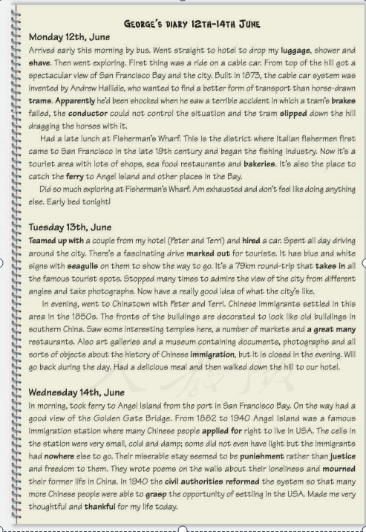

Task 4. Read the passage again and underline the useful expressions related to travel journals.go straight to my hotel to drop my luggage / go exploring /get a spectacular view of / get a ride on the cable car/ it is a tourist area with lots of shops, sea food restaurants and bakeries / do much exploring / team up with / a round-trip that takes in all the famous tourist spots / admire the view of / see interesting temples, a number of markets and a great many restaurants / art galleries and a museum containing documents, photographs and all sorts of objects about the history of Chinese immigration / take ferry to / have a good view of

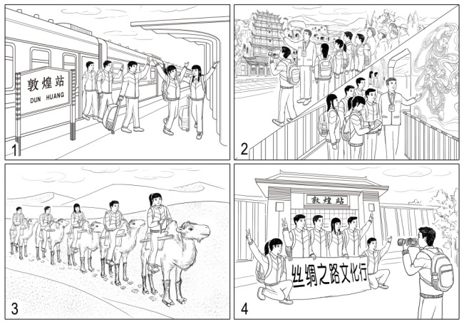Task 5. Imagine you went to Dunhuang on holiday. Write an email to your friend Jim telling him about your trip.

Picture 1

Picture 2

Picture 3

Picture 4

|  |
| --- |
|  |