**高三年级(上)英语第4课时(第1周) 学习指南：M8U1 听说**

目标与建议：

听录音回答问题，并补全乔治的明信片，整理有用表达，学习如何使用“方位和未知”（Direction and position）的表达法来介绍一个地方或描述一个事件，以及在口语中鼓励别人说话的方法，并完成一段对话练习。

Task 1. Listen to the tape and answer the questions.

1. Where did George's tour start and in which direction has he been travelling?

2. What surprised George about California?

3. Why did George have the wrong idea about California before he went there?

1. Why are there so many different kinds of music, food and art in California?

Task 2. Listen to the tape again and complete the postcard George wrote. (P6)

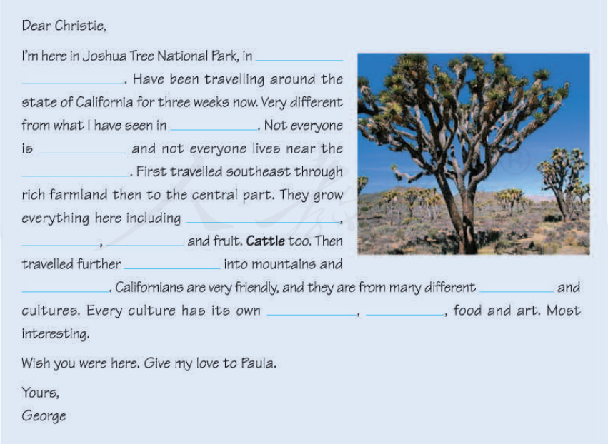

Task 3. Listen to the tape again and underline the questions and expressions that Christie uses.

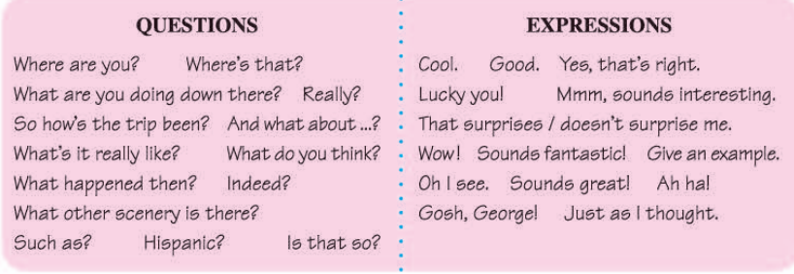

Task 4. In pairs hold a telephone conversation about a place you have visited recently. Try to use the expressions you have learnt to indicate that you are listening carefully to your partner.

Partner A: Talk about where the place is, what the climate is like, what you thought about the people, and any other interesting things you saw and did.

Partner B: Encourage your partner to talk by asking questions and making comments.

Sample dialogue

Partner A: Hi, Bruce.

Partner B: Hi, Alexis. Where are you?

Partner A: I am on the top of the Great Wall.

Partner B: Wow, where is that?

Partner A: It is in Beijing, China.

Partner B: Tell me more about it. I am dying to know more about this fantastic place.

Partner A: Beijing is the capital of China. It covers 16,800 square kilometers. It is surrounded by mountains to the north and west.

Partner B: Lucky you. What are you doing down there?

Partner A: I am visiting the famous scenic spots in Beijing and experiencing the life of the local people.

Partner B: Cool, so how has the trip been?

Partner A: Jolly good. There is so much to see and it is nothing like what I imagined.

Partner B: Really?

Partner A: I expected to pay for everything in cash so I exchanged a lot of RMB and take with me everywhere I go.

Partner B: Oh, you don’t need any cash?

Partner A: Everything can be paid through mobile phones, WeChat, Alipay…. They are just so convenient. I mean everywhere you go, to the scenic spots, to the supermarket, to the shopping mall, you name that.

Partner B: What scenic spots are there?

Partner A: Beijing was the capital of many dynasties in Chinese history and these dynasties left a large number of architectural souvenirs in the city: the Forbidden City, the Summer Palace, and the Temple of Heaven. There is also a legacy of royal parks: Jingshan Park and Beihai Park.

Partner B: Sounds fantastic. I wish I could see them for myself. How are the people there?

Partner A: Oh, they are nice and friendly. Many people can speak English. They are also very polite and modest.

Partner B: Wonderful.

Partner A: I will call you again to tell you more about my trip.

Partner B: OK. Wish you a pleasant trip. Bye for now.

Partner A: Thank you. Bye.