**8年级（上）英语第3课时（第1周）**

**《英语动词变变变!》学习指南**

**【学习目标】**

1. 能够归纳总结一般现在时，现在进行时，一般将来时，一般过去时的意义，结构和判断时态的关键词；

2. 能够运用所学的四种时态描述日常生活。

**【学习任务】**

**任务1：1 Draw a mind map about the simple past tense and the future tense in your own way.**

**任务2： Complete the dialogues with the correct form of the words**

1. — When do you usually get up on weekends?

— I usually **__________** (get) up at 8:30.

2. — What will our life be like in the future?

— We **__________** (travel) by flying car.

3. — Are you going to **__________** (swim) in the sea?

— Yes, I am. I **__________** (like) swimming. I **__________** (begin) to swim when I was eight.

4. —**__________** you **__________** (do) your homework now?

— Yes, I am. Don't push me. I **__________** (finish) it in half an hour.

**任务3：Listen and choose the correct answers.**

It was Sunday. I never get up early on Sundays. I sometimes **__________** (stay / stayed) in bed until lunch time. Last Sunday, I **__________** (get up / got up) very late. I looked out of the window. It **__________** (is / was) dark outside. “What a day!” I thought. “It’s raining again.” Just then, the telephone **__________** (ring / rang). It was my aunt Lucy. “I’ve just arrived by train,” she said. “**__________** (I’m coming / I came) to see you.”

“But I’m still having breakfast,” I said.

“What are you doing?” She **__________** (asks / asked).

“I’m having breakfast,” I repeated.

“Dear me!” She said. “Do you always get up so late? It’s one o’clock!”

**任务4：**学校的英语角正在开展“用英语介绍学校的过去、现在和对未来的展望”的主题活动。希望同学们积极收集和整理信息，在英语角活动中进行分享。

Introduce your school in the past, at present and in the future.

the school size

the position of the school buildings

the environment of your school

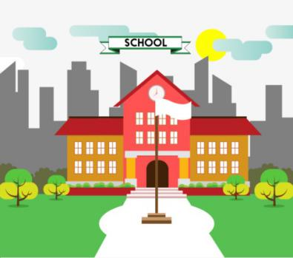

more information you want to introduce

__________________________________________________________________________________________________________________________________________________________________________________________________________________________________________________________________________________________________________________________________________________________________________________________________________________________________________________________________________________________________________________________________________________________________________________________________________________________________________________________________________________________________________________________________________________________________________________________________________________________________________________________________________________________________________________________________________________________________

**8年级（上）英语第3课时（第1周）**

**《英语动词变变变!》学习指南参考答案**

任务4：

In the past our school was small. Now it is very big and beautiful. You can see green trees and flowers in spring and summer. Maybe in the future there will be a small garden with a fountain in the middle of it.

In the past you could see a few houses. Now there are some modern buildings. You can see a science building behind a library. Maybe in the future more buildings will stand in my school.

In the past the playground was old and small. Now it is very clean and big. Maybe in the future there will be a sports hall.

I hope our school will be more and more beautiful.