**学程拓展**

**UNIT 1 WHY ARE YOU SO HAPPY?**

**LESSON 1 (1)**

题目

( ) 1. Which feeling is the same as glad?

A. happy B. sad C. angry

( ) 2. Nina is so happy. We really want to know the reason. How

can we ask her feeling?

A. Why are you so happy?

B. Why do you look so angry?

C. I’m so happy for you.

3. 看图读句子，在横线上写出恰当的单词补全句子。

(1) Bob is __________, because he gets a nice gift on

Children’s Day. He likes it very much.

(2) David’s dad is _________, because David’s room is messy.

He needs to clean it.

(3) Cindy plays the piano too hard. She looks _________.

4. 请根据情境，补全对话。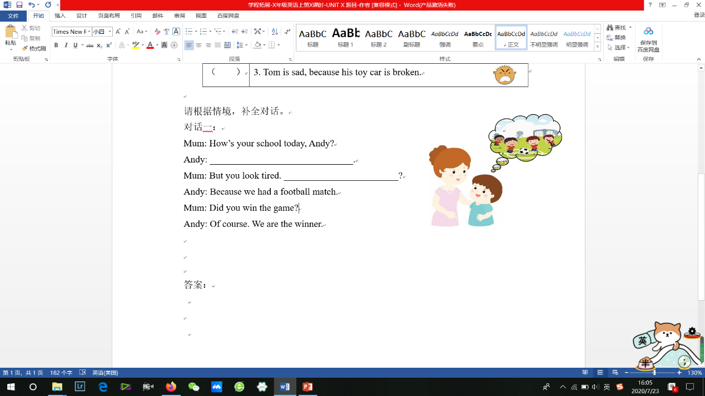

Mum: How’s your school today, Andy?

Andy: Great! We are glad to see each other again.

Mum: But you look tired.________________________?

Andy: Because we had a football match.

Mum: Did you win the game?

Andy: Of course. We are winners.

5. When do you feel happy?

_____________________________________________________________________

答案：

1. A

2. A

3. happy, angry, tired

4. 略

5. 略