**学程拓展**

**UNIT 1 SEPTEMBER 10TH IS TEACHERS’DAY**

**LESSON 3 (1)**

题目

Read and choose.根据对话内容，选择填空。

1.______________(Teacher’s Day, Teachers’ Day)is coming.

2.Teachers’ Day is on September the ___________(ninth, tenth).

3.Maomao will __________(make cards, make flowers)for their teachers.

4.Let’s make cards for our teachers.(教师节即将来临，请你仿照左边的贺卡，给老师们设计一个漂亮的卡片吧。)

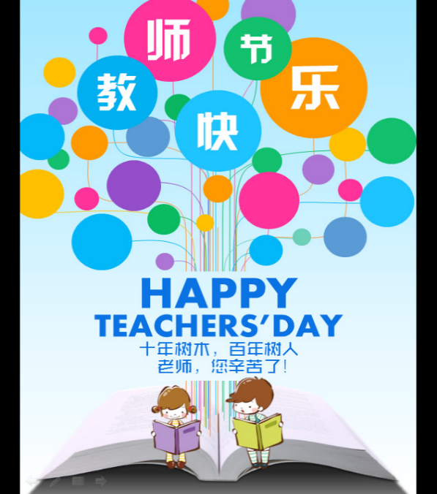

5.教师节即将来临，请你为老师做一件事，可以写出来，也可以画出来哦。

答案：

Read and choose.

1.Teachers’Day 2.tenth 3.make cards

4.答案不唯一

5.答案不唯一