**学程拓展**

**UNIT 1 SEPTEMBER 10TH IS TEACHERS’DAY**

**LESSON 3 (2)**

题目

根据问句，完成答语。

1.When is Teachers’ Day? It’s _______________ the ______________.

2.---Is your first class Chinese today?

--- _____________

A. Yes, it is. B. No, it isn’t. C. I like Chinese.

3.Read and write.(根据生活实际填写相应的序数词。)

Today is September the __________.

I live on the ____________ floor(楼层).

|  |  |
| --- | --- |
| Monday | |
| 1 | Maths |
| 2 | Chinese |
| 3 | English |
| 4 | PE |
|  |  |
| 5 | Music |
| 6 | Art |

I sit in the _____________ row.

4.看右边的课表，仿照例子写句子。

例：The first class on Monday is Maths.

The ________ class on Monday is _______.

______________________________________.

5.看图，根据所给的单词完成短文。

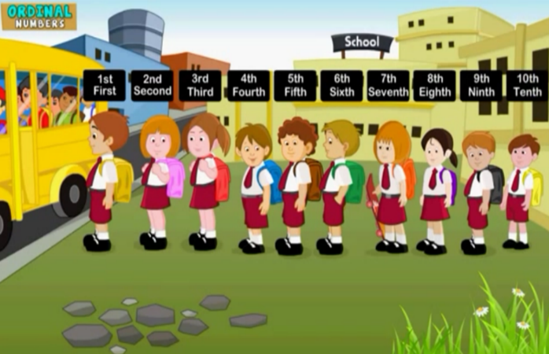

|  |
| --- |
| green second  name seventh |

Look, the children go to school on the school bus. The boy with the yellow bag is in the first position（位置）. He is my friend. His _______ is David. The girl with the purple bag is in the ___________ position. She is Mary. The boy with the _____________ bag is in the sixth position. He is Tom. The girl with the orange bag is in the __________ position. And she has a skateboard.

答案：

1.September tenth

2. 答案不唯一（A或B）。

3. 答案不唯一。

4. second Chinese(答案不唯一)

The fifth class on Monday is Music. (答案不唯一)

5. name, second, green, seventh.