**学程拓展**

**UNIT 1 SEPTEMBER 10TH IS TEACHERS’DAY**

**LESSON２(2)**

题目

Read and choose.根据对话内容，选择填空。

1.We have two new _________(teachers, pupils).

2.Sara is American. And Mike is from ___________(Canada, China).

3.Mike sits in the second ___________(row, class).

4.Listen and choose.听课上录音，完成表格。

|  |
| --- |
| Chinese English Maths PE |

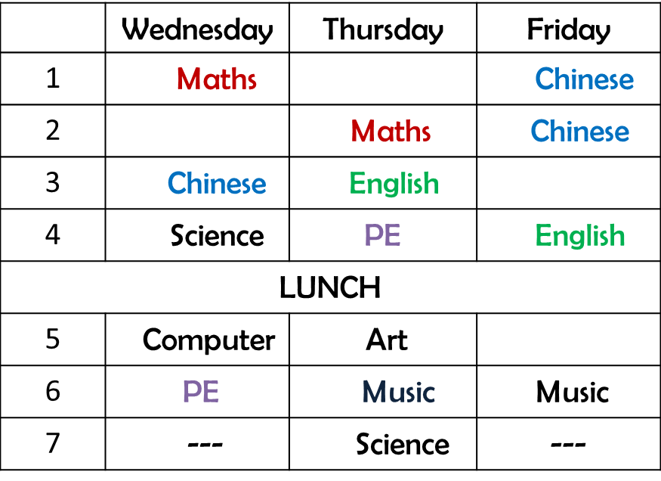

5.Let’s make.制作自己的英文课表。（P5）

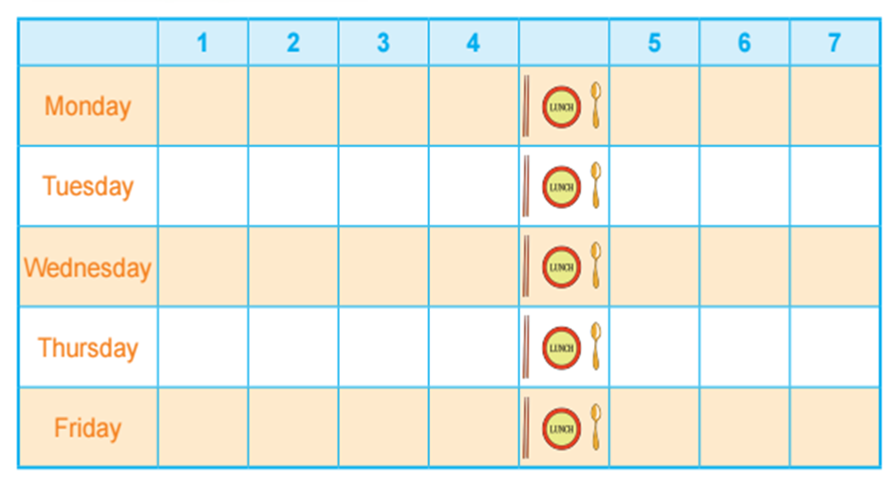

答案：

Read and choose.

1.pupils 2.Canada 3.row

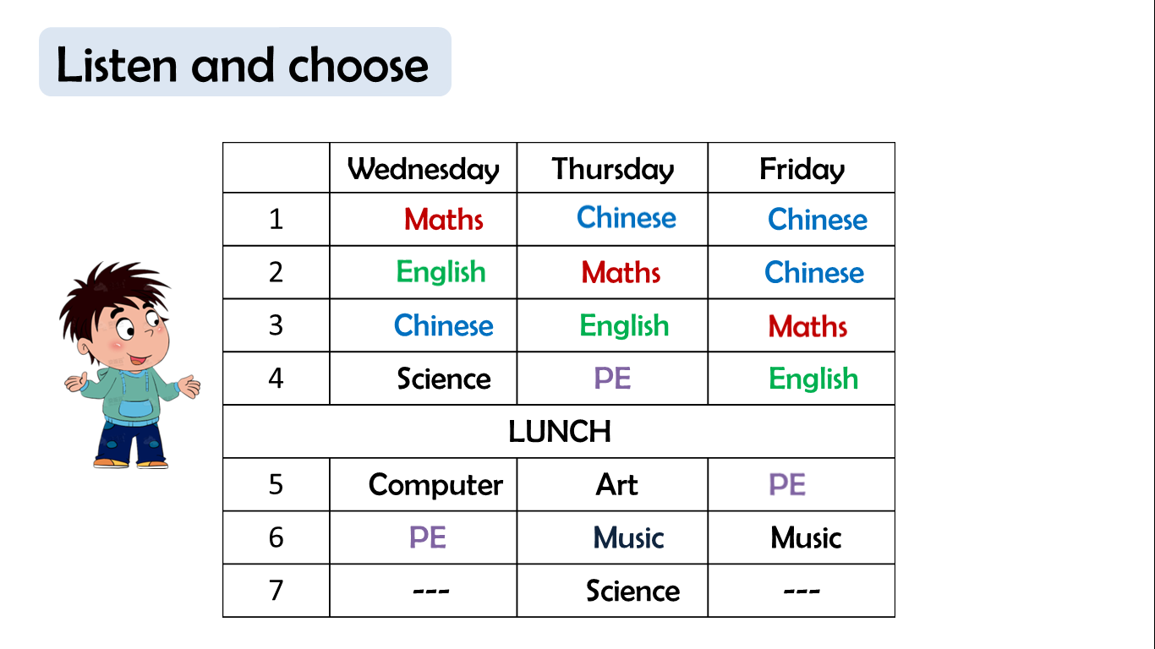4.Listen and choose.

5.Let’s make.(答案不唯一)

