**Unit 8 Green living**

**Lesson 3 “ White Bikes” on the Road (1) ——学习任务单**

**【学习目标】**

1.能够通过阅读，获取 “白色单车”的事实性信息，如背景条件、发展过程以及影响；

2.能够口头介绍“白色单车” 的发展过程；

3.能够认识到绿色出行的意义和面临的挑战，认识到事物的发展必然会经历挫折，人们要直面问题、坚持不懈地努力。

**【学法指导】**

1.阅读时，关注事物的发展过程：起源、发展和结果；

2.能够使用可视化图表，梳理事物的发展过程。

**Task 1: Talk about shared bikes.**

1. Have you ever used shared bikes?

2. Why do you use shared bikes?

3. Is there any disadvantage of shared bikes?

**Task 2: Read to know about “the City of Bicycles”-Amsterdam.**

1. Why is it a good city for cycling? Read the first paragraph and take notes about the reasons.

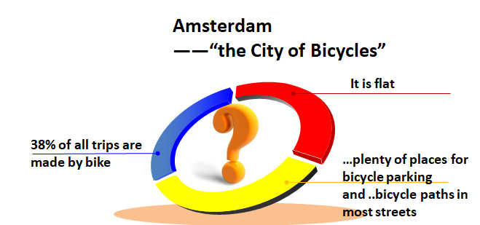

**Task 3: Skill Builder: Development of events.**

Read the Skill Build (P37) to understand development of events.

**Task 4: Read to learn the development of the “white bikes”.**

1. Please read the rest of the text to find out about the development of the “White Bikes”. Underline the key information.

* When did the idea of “white bikes” start?
* When did the “white bikes” return?
* What is the situation now?

2.Read the passage again and answer the following questions.

**Start (in the 1960s)**

1. Who put forward the idea and why? What did they do?

2. What happened to it soon after?

**Return ( in 1999)**

3. What is the difference between the “white bikes” and the 1960s and of the 1999?

**Now**

4. What effects have “white bikes” had on Amsterdam?

5. Why has the idea spread to other parts of the world in recent years?

6. What about the shared bikes in China?

**Task 5:** **Oral Presentation.**

Suppose you are giving a presentation about “white bikes” in Amsterdam to the audience.  
Please try to introduce it with the help of the flow chart. (P38)

**Task 6: Voice your opinion**

1. What does the title “‘White Bikes’ on the Road” mean?

2. From the development of bike-sharing in Amsterdam and in China, what can you learn?

**Homework:**

Choose one.

1. Make a survey on shared-bikes in China. And draw flow chart of its development.

2. Make a survey on carpooling. You can draw a flow chart of its development.