**“绿色生活” Writing Workshop: A Survey Report (1)**

**学习目标**

1. To read and understand a survey report
2. To identify the main idea of each paragraph and label it correctly
3. To read and understand graphs
4. To use expressions relating to quantity

**学法指导**

在学习时，同学们务必关注：

1. 调查报告的文本结构，组成部分和具体内容；
2. 调查报告的语言句式特点，尤其是运用多种方法进行定量表达。

**学习过程**

**1.Get ready for writing**

What should be included in a survey report on environmental protection?

What kind of survey is good?

**2.Read for idea**

Read the survey and answer the questions.

1) Who conducted the survey?

1. When and where was the survey conducted?
2. How many people took part in the survey?
3. What’s the purpose of the survey?
4. What questions are asked?

6) What are the findings?

1. **Read for Structure**
2. Read the survey again and label each paragraph of the report with different headings.

a . Introduction c. Negative findings

b . Conclusion d. Positive findings

1. Finish the following chart

|  |  |
| --- | --- |
| Topics | Details |
| introduction |  |
| positive findings |  |
| negative findings |  |
| conclusion |  |

**4. Read for Language**

1) Read the survey and finish Ex. 4 on page 41. Underline the quantity expressions in the survey report

2）Think and Answer

Why does the author use quantity expressions?

Please give more quantity expressions.

**5 . Practice**

Describe pie charts(spending patterns in America)

Please use proper quantity expressions.

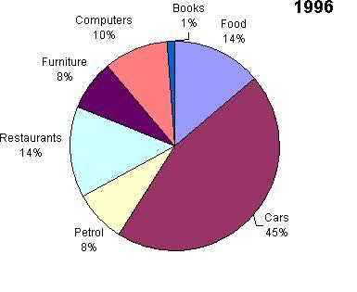

**学习总结**

通过本节课的学习

1.获取调查报告中呈现的关于市民环保意识和行为的事实性信息(如调查的时间和地点、目的、参加的人员、调查的具体问题和基本发现等)；

2.梳理调查报告的文本结构,辨别调查报告的组成部分及具体内容；

3.辨别调查报告典型的语言句式特点,尤其是运用多种方法进行定量表述；

4.初步运用不同的语言句式和简单的图表(饼状图与柱状图)进行定量表述。