**8年级英语第38课时**

**《语言知识的灵活运用—Module 6》学习指南**

**【学习目标】**

1. 总结本模块关于“爱好”的重点短语和句式，并能在新的语境中正确运用这些表达方式；
2. 梳理第六模块的语法，即简单句的六种基本句型, 并能在“爱好”话题写作中正确使用；
3. 能运用本模块重点表达方式和语法笔头介绍自己的爱好。

**【学习任务单】**

**任务一：课前预习**

一、根据中文提示，划出Module 6 Unit 1和Unit 2两篇课文中关于“爱好”的短语。

Module 6 Unit 2

1. 比如 2. 促使你成长

3. 培养你的兴趣 4. 学习新技能

5. 其中之一 6. 除…之外，还有

7. 鼓励某人做某事 8. 结果，因此

9. 带给某人快乐和成功 10. 对…感兴趣

Module 6 Unit 1

1. 给某人扇子作为礼物

2. 把某物展示给某人看

3. 集邮

4. 和…一样多

5. 重要的东西

6. 在某人的一生中

二、找出与中文含义相匹配的英文短语并连线。

Module 6 Unit 1

1. give sb. fans as presents
2. collect stamps
3. as much as / as many as
4. something important
5. in one’s life
6. show sb. sth.

1. 在某人的一生中

2. 集邮

3. 给某人扇子作为礼物

4. 和…一样多

5. 重要的东西

6. 把某物展示给某人看

Module 6 Unit 2

1. make you grow as a person
2. as a result
3. one of…
4. develop your interests
5. learn new skills
6. bring sb. pleasure and success
7. as well as
8. encourage sb. to do sth.
9. such as
10. be interested in…
11. be interested in…

1. 结果，因此

2. 其中之一

3. 促使你成长

4. 带给某人快乐和成功

5. 学习新技能

6. 除…之外，还有

7. 鼓励某人做某事

8. 对…感兴趣

9. 培养你的兴趣

10. 比如

**任务二：“爱好”的基本句型知多少**

一、句型转换。

1. Lucy sent me a message. _____________________________________________

2. Bob showed his new watch to me. _____________________________________________

3. My sister made me a cake. _____________________________________________

4. 我妈妈给我买了条新裙子。（请写出两种句式）

① _____________________________________________

② _____________________________________________

二、总结：简单句的六种基本句型

1. ___________________________________

2. ___________________________________

3. ___________________________________

4. ___________________________________

5. ___________________________________

6. ___________________________________

三、结合所学句型，翻译句子。

1. 我的其中一个爱好是看书。______________________________________________________

2. 当我五岁的时候，我妈妈给了我一本书作为生日礼物。

_____________________________________________________________________________

3. 这本书是关于两个男孩的故事。__________________________________________________

4. 这本书很有意思。______________________________________________________________

5. 从此，读书成为我生活的一部分。__________________________________________________

6. 读书能促使我成长。_____________________________________________________________

7. 它带给我快乐。________________________________________________________________

8. 我爱读书。_____________________________________________________________________

**任务三：“爱好”的文段表达知多少**

一、划出结构不正确或者句型不恰当的句子。

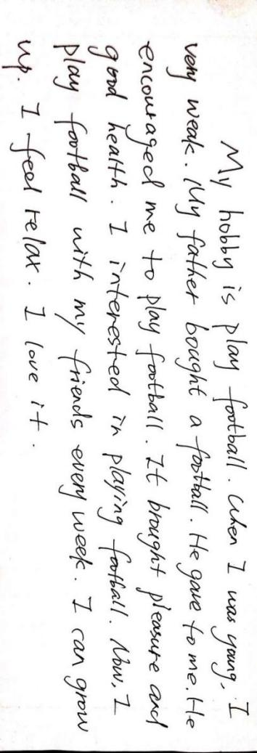

二、运用所学的句型修改文段。

1. _____________________________________________________________________________

2. _____________________________________________________________________________

3. _____________________________________________________________________________

4. _____________________________________________________________________________

5. _____________________________________________________________________________

6. _____________________________________________________________________________