**8年级英语第37课时**

**《语言知识的灵活运用—Module 5》拓展资源**

阅读短文，根据短文内容回答问题。

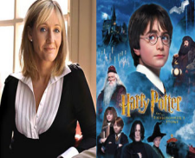J.K. Rowling was born in England in 1965. She loved reading, and wrote her first story *Rabbit* when she was only six years old. She studied French at university, and then worked as a secretary in London. She had the idea for *Harry Potter* when she was on a train. “Harry just walked into my head,” she said later. She started writing the first book *Harry Potter* the next day.

In 1992 she went to Portugal and lived there for three years. She wrote *Harry Potter* in the morning, and worked as an English teacher in the afternoon and evening.

She got married to a Portuguese TV journalist and had a daughter called Jessica.

Then she returned to Britain and lived in Edinburgh, in Scotland. She didn’t have a job at that time, and wrote in cafés because they were warmer than her small flat. After five years she finished the first book *Harry Potter and the Philosopher’s Stone*. The book was sold millions of copies all over the world, and Joanne Kathleen Rowling became very famous. She is now very rich, but she still writes her books in cafés!

1. In which year did J.K. Rowling write her first story?

____________________________________________________________

2. What was her first job?

____________________________________________________________

3. What did she spend her afternoons and evenings doing in Portugal?

____________________________________________________________

4. Why did she write in cafés?

____________________________________________________________

5. What is she famous for?

____________________________________________________________