Unit 8 Lesson2 Greening the desert(1)课后练习

I. 单句语法填空

1.2018·江苏卷] It can be concluded that restaurant keepers need not "be overly concerned about bad’ tables,” given that they’re ______(profit).

2.[208·北京卷]Also, sometimes pre-anger does not have to do with a lasting condition, but rather a temporary state before a triggering event _______ (occur).

3.2018·江苏卷]From2004 to 2013, ________ (agriculture) land values doubled, and they continue to rise in many regions.

4.[2019·天津卷] Submit a topic _______ (propose) to your history teacher.

5.[2019·全国Ⅱ卷] You will surely need _______(overcome) some difficulties, some planned, but most un-planned.

6.[2019·北京卷] With her talent and_________(determine), it appears that the sky could be the limit for Alice Moore.

7.[2019·北京卷] These developments are likely to make our __________ (currency) problems with robocalls much worse.

8. [2018·全国Ⅲ卷] Yesterday, I sat with my son, Shepherd, _________ (determine) to test my own

theory on this.

II. 阅读理解

Green the desert project

百万森林计划：把绿色还给地球

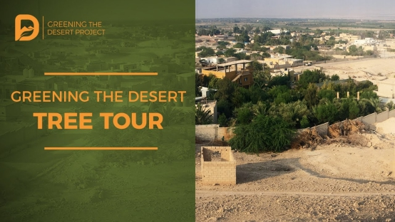

Four years after graduation from college, Luo Jiajia answered an inner (内心的) calling to lead a more meaningful life. At that time, Luo noticed that environmental issues were becoming more serious, but few actions were being taken to address the situation. She decided to join environmental protection efforts, so that future generations may also enjoy nature.

Now, Luo, 36, works at China Green Foundation (CGF) – an NGO that raises money to promote reforestation (再造林) and mobilize (动员) participants in environmental protection.

It’s also active beyond China. While working at CGF, Luo served as chair of the Civil Society Organization Panel of  the United Nations Convention to Combat Desertification (《联合国防治沙漠化公约》). This allowed her to attend UN meetings.

Luo’s main work focuses on the Million Forest project. Launched 10 years ago, the project aimed to plant 1 million trees to help manage the problem of desertification around China’s fourth-largest desert, the Tengger Desert of Inner Mongolia. The ongoing project has exceeded (超过) its original goal. It has seen more than 100 million trees planted! Luo helps support the project by brainstorming different fundraising (募款) activities and organizing events.

The project has brought about many benefits to the local communities. Without the efforts of CGF and the Million Forest project, many locals would have been forced to leave their homes as eco-refugees (生态难民). Luo’s project has also provided jobs to local residents (居民). In addition to being paid to help plant the trees, locals can also profit from selling fruit produced by the trees. Eco-tourism (生态旅游) has also flourished (蓬勃发展) because of these green spaces.

Reflecting on Million Forest, Luo had a lot to say. She says she learned a lot from the project. “Nature has its own rhythm and wisdom,” she said. “We should respect it.”

Although her project helps with reforestation efforts, the team discovered that it was just as important to change people’s attitudes. Million Forest changed its slogan (口号) to, “Plant a tree in your heart.” Commenting on the change, Luo said，“It’s not possible for you to plant a tree every day, but if you have a tree in your heart then you can take care of the whole environment ... If we make the effort to change the inside, we can change the outside world.”

（选自China Daily）

**1. What is Luo’s main work at CGF?**

A. Attending UN meetings as a CGF representative.

B. Selecting volunteers to work for CGF.

C. Providing support for the Million Forest project.

D. Promoting eco-tourism in the Tengger Desert of Inner Mongolia.

**2. How has the Million Forest project helped local communities?**

A. It has provided jobs for eco-refugees.

B. It has offered locals a chance to make money.

C. It has helped locals sell fruit across the country.

D. It has encouraged locals to leave their hometown to work.

**3. Why did Million Forest change its slogan according to Luo?**

A. To celebrate achieving its goals.

B. To call on people to plant as many trees as they can.

C. To show people the importance of reforestation.

D. To remind people to have environmental protection in mind.