**话题：人与社会《科学与技术》Listening and Speaking学案[学习目标]** 本节课学生通过听和说的练习了解不同机器人的种类和功能，并充分发挥想象力设计自己的机器并向他人介绍其外表都和功能。

**[学法指导]** 学生通过听的练习，掌握听力材料的主要内容和重要细节，并学习与机器人相关的词汇。学生通过说的练习，在新语境中运用所学的词汇。

**I. Warming up:**

Talk about what robots may look like and what robots can do.

**II. Pre-listening：**

Look at the pictures of the robots. What do you think each one does?

**III. While- Listening:**

**Task 1:** Now listen and number the pictures in the order you hear about them.

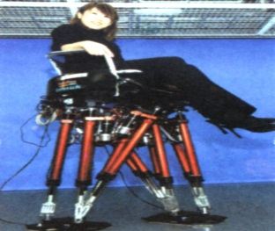 （ ） 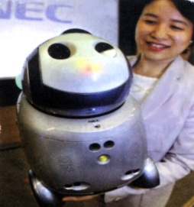 （ ）

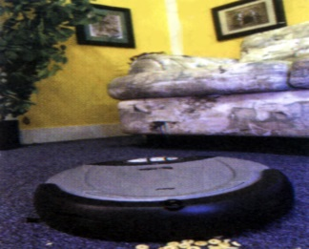 （ ） 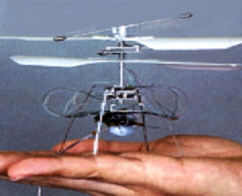（ ）

**Task 2:**. Listen twice and complete the sentences.

1. A carpet cleaner can _____ from house to house, _________ your house. You can _________ it to

clean when you’re away and you can ________ it from your computer at the office.

2) “PaPeRo” is an __________ personal robot. It can__________650 phrases, _______more than

3000 words, _________ different people, ______ your email, help children ___________ on the

Internet , ____ to them about their day at school and even __________ with them.

3) A tiny robot plane weighs 9 grams and has a ________. It will be used to ____ into dangerous areas

and ______ if anyone is trapped inside. So it could ______ a lot of people’s lives.

4) A walking chair helps people who can’t walk to _____________ stairs.

**III. Post- Listening:**

Task1:Talk about the four robots according to the pictures.

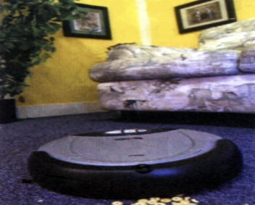 

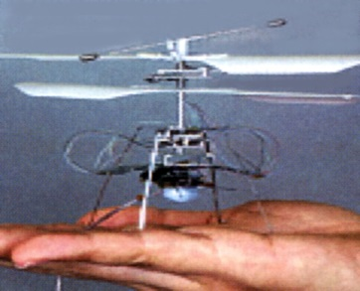 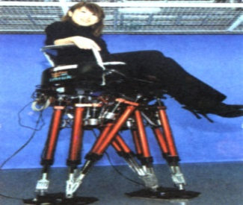

Task 2: Voice your opinions : What may be the negative effects of each robot?

Task 3: Design your own robot and introduce it to your classmates. Your description includes:

Useful expressions:

It’s a personal/industrial robot.

It is …shaped.

It weighs……

It will be used to……

It will be able to……

It will help……

It can ……

**Homework**

Listen to Amanda, Victoria and Jamie talking about robot pets and finish the exercises.