**M7U1课后作业**

**Writing Task**

针对即将到来的复课，学校正在广泛征求各位同学的建议，请以一名高二学生的身份，就校园复课的潜在隐患给校长写一封建议信。信中应包含以下内容：

1. 写信目的

2. 对校园复课可能潜在的问题简要评述。

3. 针对问提题出建议。

Step 1 Draw a mind map to include the main topic for each paragraph. the key aspects of each paragraph and the according key expressions.

Step 2 First draft writing

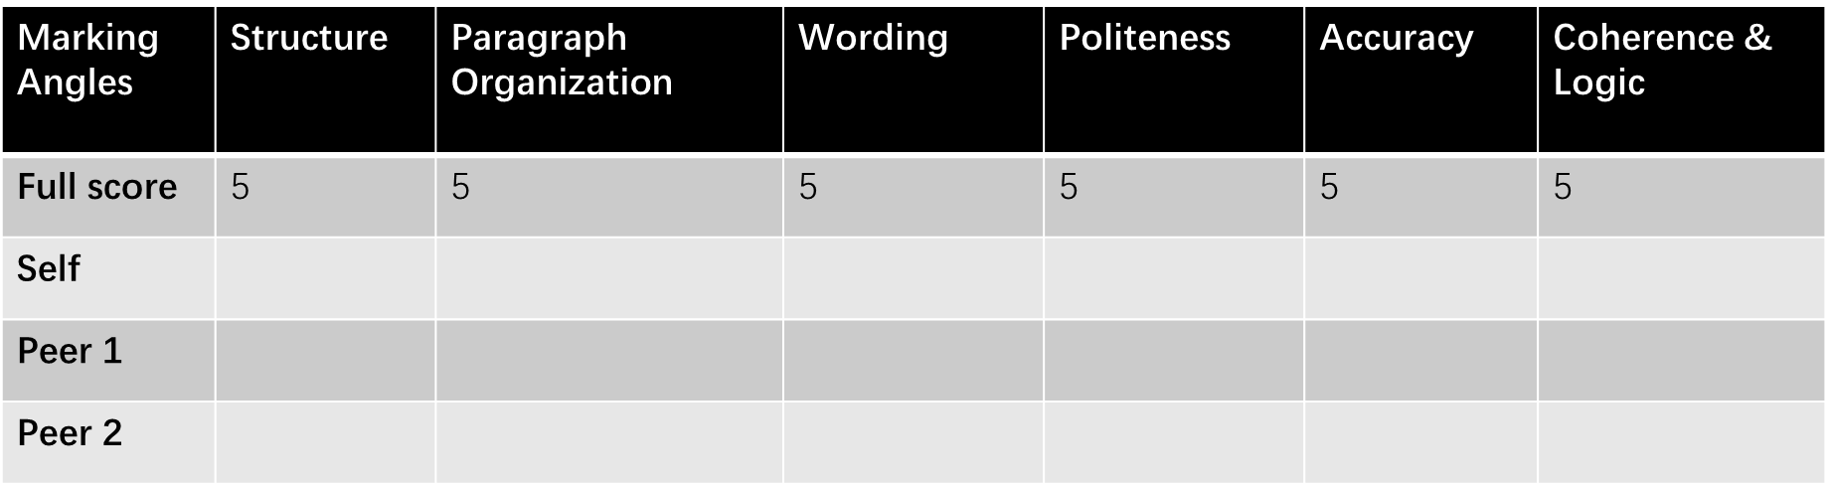

**Draft 1**

_____________________________________________________________________________________________________________________

_____________________________________________________________________________________________________________________

_____________________________________________________________________________________________________________________

_____________________________________________________________________________________________________________________

_____________________________________________________________________________________________________________________

_____________________________________________________________________________________________________________________

_____________________________________________________________________________________________________________________

_____________________________________________________________________________________________________________________

_____________________________________________________________________________________________________________________

_____________________________________________________________________________________________________________________

_____________________________________________________________________________________________________________________

_____________________________________________________________________________________________________________________

_____________________________________________________________________________________________________________________

_____________________________________________________________________________________________________________________

_____________________________________________________________________________________________________________________

**Step 3 Peer editing**

**Highlight 1:**

**Highlight 2:**

**Highlight 3:**

**Mistake 1:**

**Mistake 2:**

**Mistake 3:**

Homework: Polish Draft 1 to create Draft 2.