**A letter to an architect 读写学案**

**Task 1 Talking**

**What possible problems will there be if our school life comes back to normal?**

**Considering such problems, what are the possible solutions?**

**Task 2 Brainstorm**

**What makes a good letter of advice?**

**Task 3 Prediction**

**How many parts do you expect to read in a letter of suggestion?**

**What does each part talk about?**

**Task 4 Reading for information**

**Read and answer:**

1. **Who is the letter from?**
2. **What’s the name of the architect?**
3. **Why does Alice Major write the letter?**
4. **How many suggestions are given here?**

**Task 5 Reading for writing strategies & language**

**Draw a mind map to include the key aspects of each paragraph and the according key expressions.**

**Task 6 Tip summary**

What are the four tips mentioned in this lesson?

Tip1:________________________________________________________________________________________

Tip2:________________________________________________________________________________________

Tip3:________________________________________________________________________________________

Tip4:________________________________________________________________________________________

**Task 7 Brainstorming**

**In groups, brainstorm as many relevant expressions as you can.**

|  |  |  |  |  |  |
| --- | --- | --- | --- | --- | --- |
| **background** |  | **reason** |  | **transition** |  |
| **benefit** |  | **purpose** |  | **appreciation** |  |
| **problem** |  | **hope** |  | **suggestion** |  |

Task 8 Writing

**Writing Task**

针对即将到来的复课，学校正在广泛征求各位同学的建议，请以一名高二学生的身份，就校园复课的潜在隐患给校长写一封建议信。信中应包含以下内容：

1. 写信目的

2. 对校园复课可能潜在的问题简要评述。

3. 针对问提题出建议。

Step 1 Draw a mind map to include the main topic for each paragraph. the key aspects of each paragraph and the according key expressions.

Step 2 First draft writing

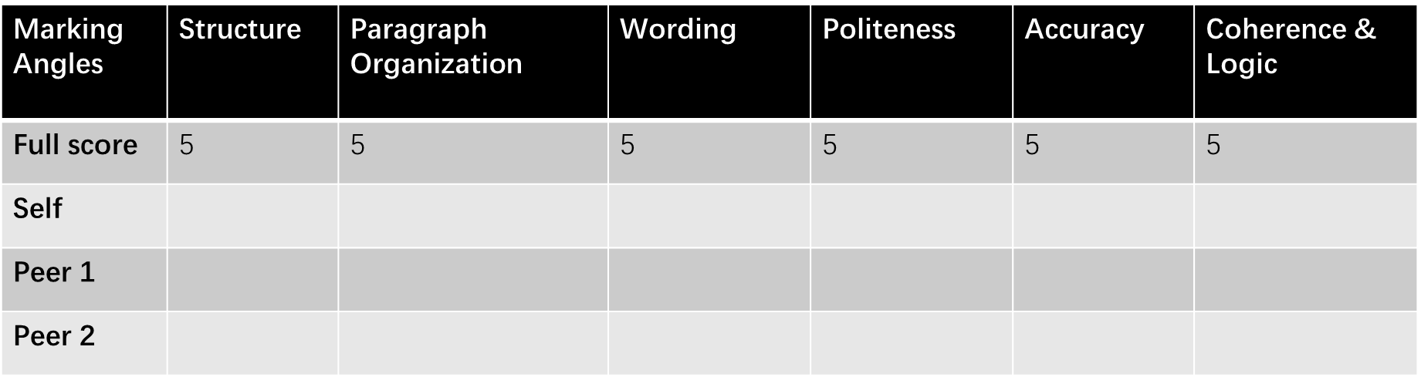

**Draft 1**

_____________________________________________________________________________________________________________________

_____________________________________________________________________________________________________________________

_____________________________________________________________________________________________________________________

_____________________________________________________________________________________________________________________

_____________________________________________________________________________________________________________________

_____________________________________________________________________________________________________________________

_____________________________________________________________________________________________________________________

_____________________________________________________________________________________________________________________

_____________________________________________________________________________________________________________________

_____________________________________________________________________________________________________________________

_____________________________________________________________________________________________________________________

_____________________________________________________________________________________________________________________

_____________________________________________________________________________________________________________________

_____________________________________________________________________________________________________________________

_____________________________________________________________________________________________________________________

**Step 3 Peer editing**

**Highlight 1:**

**Highlight 2:**

**Highlight 3:**

**Mistake 1:**

**Mistake 2:**

**Mistake 3:**

Homework: Polish Draft 1 to create Draft 2.