**An amazing achievement听说作业**

**Work with your partner and make up an interview between Marty and a journalist about his amazing achievement. Use proper expressions to show congratulations and best wishes.**

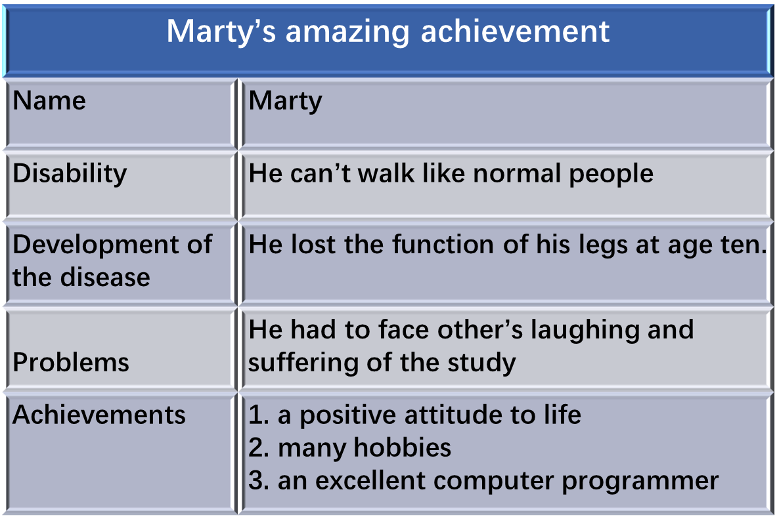

**Discussion**

**What does Barry and Marty share in common besides their disability?**