**An amazing achievement听说学案**

**Task 1 Prediction**

**According to the title and key words, make a prediction the passage!**

**Task 2 Listening for the gist**

**1. What is the achievement?**

**2. Why is it amazing?**

**Task 3 Listen and fill in the blank.**

|  |  |
| --- | --- |
| **An amazing achievement** | |
| **Climbers** | **1. Half of the group are _________________ or blind people.**  **2. The other half are sighted companions.** |
| **Reason** | **1. To ____________that the disabled can achieve whatever they decided to do.**  **2. To ________________ for the people with weak sight.** |
| **Mount Kilimanjaro** | **The highest mountain in Africa (__________ meters high)** |
| **Number of the successful climbers** | 1. **disabled group: ___________** 2. **normal group: ___________** |
| **Time** | **____________ days altogether.** |

**Task 4 Listen again and retell the amazing achievement of Barry.**

***Barry Minto a special climber has just made a successful climb of Mount Kilimanjaro…***

**Task 5 Focus on how did the interviewer congratulate and send good wishes to the interviewee?**

**JOAN: Barry, welcome to our programme and congratulations on that great climb.**

**…**

**BARRY: Of the 12 poor-sighted and blind climbers, 9 made it to the top. Of the 15 sighted climbers, 7 did.**

**JOAN: _____________!**

**…**

**BARRY: 5 days to go up and 2 days to come down.**

**JOAN: Well, Barry, I'm _______ admiration for you and your ______________.**

**…**

**BARRY: Oh, I'm going to university next year, but my next climbing ambition is to go up Mount Qomolangma one day.**

**JOAN: ___________ . I wish you _________________________ , Barry.**

**Task 6 Brainstorm as many ways to express congratulations and wishes as you can.**

**Task 7 Speaking**

**In pairs make a short dialogue in which you offer congratulations and best wishes to your partner.**

**Situation A**

**A: I’m working at a new factory now.**

**B: …**

**Situation B**

**A: I invented a new computer game.**

**B: …**

**Situation C**

**A: I won the gold medal in our school sports meeting.**

**B: …**

**Task 8**

**Work with your partner and make up an interview between Marty and a journalist about his amazing achievement. Use proper expressions to show congratulations and best wishes.**

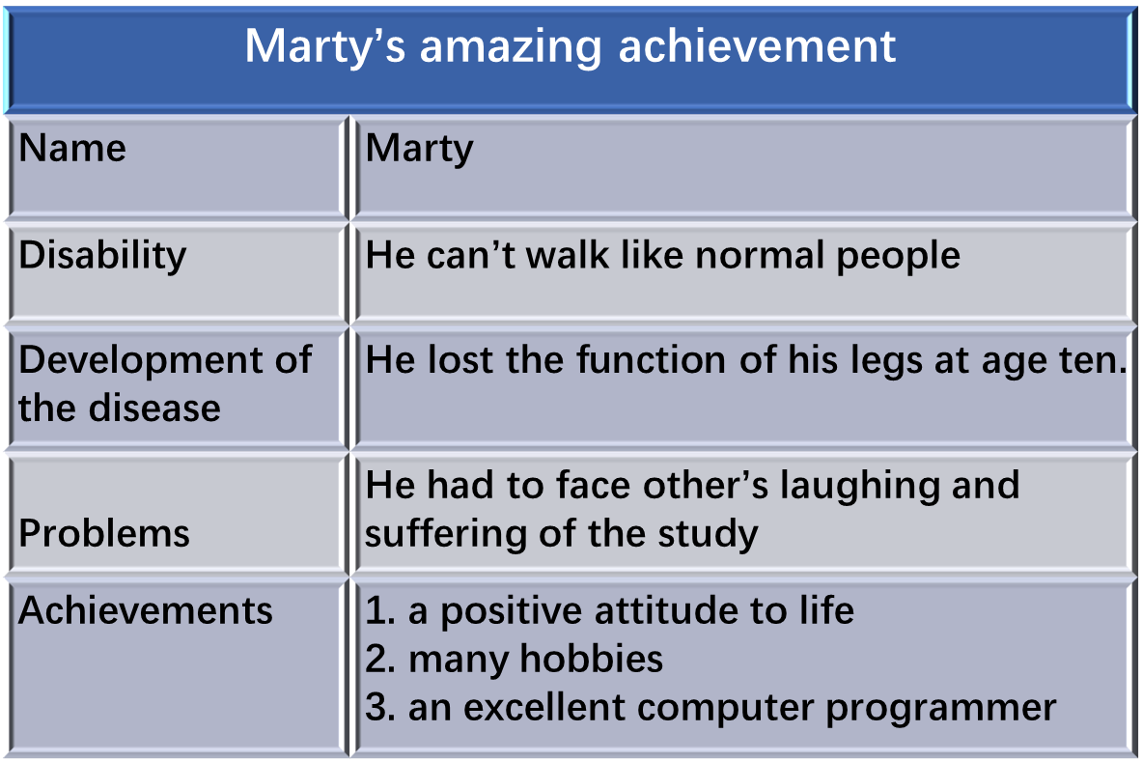

**Discussion**

**What does Barry and Marty share in common besides their disability?**