**Unit 7 Art A Formal Email (2)**

**Read the following three emails and find out the purpose of the emails.**

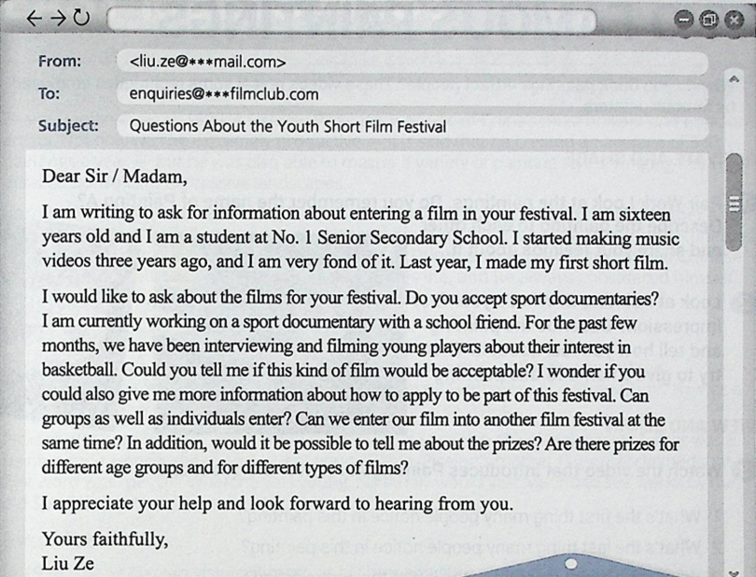

From: <liu.ze@***mail.com>

To: [lovemusic@***mail.com](mailto:lovemusic@***mail.com)

Subject: Questions About the School music competition

Dear Sir/madam,

I’m writing to ask for information about entering school music competition. I am sixteen years old and I am a student at No. 1 Senior Secondary School. I started composing music five years ago, and I am very fond of it . Recently, I have composed some music myself.

I would like to ask about the songs for your music competition. Do you accept original music or adapted music？I am currently forming a band with several school friends. For the past few months, we have been playing in different activities. Could you tell me if the popular band music would be acceptable? I wonder if you could also give me more information about how to apply to the music competition. Can groups as well as individuals enter? Is it allowed to use a playback during the performance of a competitive program? In addition, would it be possible to tell me about the prizes? Are there prizes for different age groups and for different types of songs?

I appreciate your help and look forward to hearing from you.

Yours faithfully,

Liu Ze

From: <liu.ze@***mail.com>

To: [martialarts@***mail.com](mailto:martialarts@***mail.com)

Subject: Questions About the martial arts classes

Dear Sir/madam,

I’m writing to ask for information about entering martial arts class. I am sixteen years old and I am a student at No. 1 Senior Secondary School. I am interested in Karate very much and I am a crazy fan of it.

I would like to ask about the trainings for the martial arts class. Can I take martial classes if I’m not in good shape, not very athletic and have no exercise? Although I am fond of watching martial arts competition, I have no chance to practice myself. Can I try a class or two before joining? Is martial arts training a good way to help people lose weight? Could you tell me what style of martial arts you teach? I wonder if you could also give me more information about the teachers and groups. Can you tell me how often I should I attend the class and how the groups are separated, age or rank? Should I practice between classes? Do volunteers help teach in class? In addition, would it be possible to tell me how long it takes to become proficient in Karate and how long it takes to attack the Black Belt?

I appreciate your help and look forward to hearing from you.

Yours faithfully,

Liu Ze