**话题：人与自然《全球变暖》Reading(2)+Writing课后作业答案**

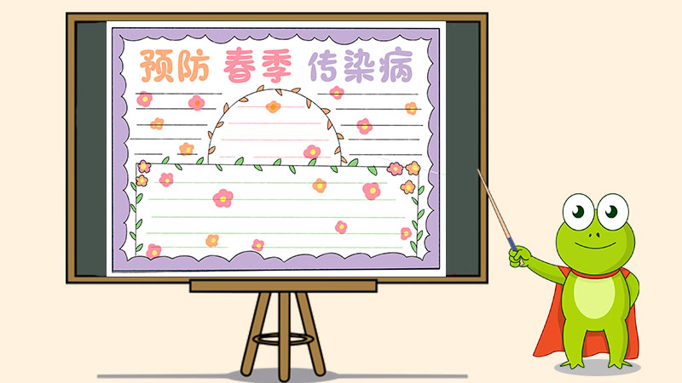

Wear masks when going out.

Wash your hands when coming back!

Keep staying at home as possible as you can

Don’t get together!

Remember what you do counts!

**Anti-Noval Coronavirs,do the right things**