**话题：人与自然《全球变暖》word study学法指导**

**[学习目标]**

1. **在真实语言情境中感悟“come about, subscribe to, quantities of ,tend to, result in, oppose, consequence”的意思、用法及相关搭配；**
2. **掌握上述7个重点词汇或语块的用法及相关搭配，理解在不同语境下词义的变化与区别。**
3. **结合语境熟练运用上述词汇或语块翻译句子；**
4. **联系个人生活，运用上述词汇或语块与好友通过书信交流中国的战疫情况。**

**[学法指导]**

1. 通过在文中寻找相关能替换新语境中的词或语块感悟它们的意思、用法及相关搭配；
2. 通过所提供的语句探究总结7个重点词汇或语块的用法及相关搭配，理解在不同语境下词意的变化和区别；
3. 通过给出的图片及汉语句子运用上述7个重点词汇或语块进行翻译句子；
4. 通过联系个人生活及对重点词或语块的学习写一封书信。

**Task 1 在阅读语篇1中找出能替换划线字体部分地单词或短语。**

**A new Coronavirus, cousin of the SARS virus, has infected more than 1 million people and caused 50 thousand people death all over the world since its outbreak in Wuhan, China. How does it happen? People are likely to believe that the virus come from bats, which contains a large amount of virus. The researchers agree on the idea that bush meat is not safe for consumption. I am firmly against that we keep on destroying our mother nature because nobody knows the worse result we would face than the epidemics of Coronavirues of 2020.**

**Task 2 导学部分**

**1.So how has this come about and does it matter? (line4)**

**This situation should not have come about.**

**It’s already 10 o’clock. I wonder how it came about that she was two hours late on such a short trip.**

**归纳 :**

**其它表“发生”的词汇**

**翻译练习：**

**练习**

**1.这么多人感染了新冠状病毒这事是怎么发生的呢？**

1. **新冠状病毒已在很多其他国家发生了。**

**2. All scientists subscribe to the view….(line18)**

**[归纳拓展]**

**He subscribe to my idea to go out for a picnic._________**

**He subscribed a large sum to the poor._________**

**He subscribed his name to the contract. __________**

**What newspaper do you subscribe to?__________**

**翻译练习**

**人们都同意我们应当保护生态平衡。**

**3.On the other hand，there are those，like George Hambley, who are opposed to this view，believe that we should not worry about high levels of carbon dioxide in the air.**

**【观察探究】**

**1)Most citizens opposed the new tax.**

**大部分市民反对新税。**

**2)The mother opposed her daughter’s going there alone.**

**这位母亲反对她女儿一个人去那儿。**

**3)I’m strongly opposed to your plan.**

**我坚决反对你的计划。**

**【归纳总结】（1）oppose是___词，意为“反对”**

**______________________反对（干）某事；**

**（2） opposed是_______词，意为___________**

**固定搭配 be opposed to sth 反对某事**

**看图练习**

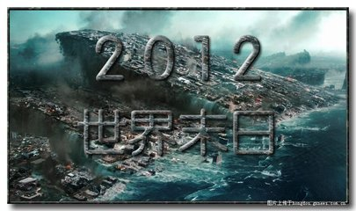

Some people subscribed to the view that the world would come to an end in 2012.

However, ____________________________________________________________________

4. It means that more heat energy tends to be trapped in the atmosphere causing the global temperature to go up.(line34)

Women tend to live longer than men.

If you eat like this, you tend towards obesity.

Interest rates are tending upwards/downwards.

He had to tend (to) patients

He has a tendency to do things differently.

短语 __________________ ______________________

___________________ ______________________

5. The problem begins when we add huge quantities of extra carbon dioxide into the atmosphere. (line32)

Without quantity there can be no quality.

Police found a (large) quantity of / large quantities of illegal drugs.

There is a large quantity of wine left.

A large quantity of air conditions have been sold since the summer came.

Huge quantities of good soil are being washed away each year.

This product is cheap to produce in quantity.

短语归纳________________________

________________________

用法归纳_____________________________________

—————————————————————

填空题：large quantities of rice _____(be) sold at a discount in the market yesterday.

填空练习：

A large quantities of virus _________ (is/are ) hosted in the body of the bat. If people eat it, they ____________get sick.

At first people ___________the view that the Noval Coronavirus were caused by the bats. But others also ___________ this view that bats should take the responsibility because humans have encroached(侵犯） on the lives of bats.

1. it is the burning of more and more fossil fuels that has resulted in this increase in carbon dioxide. (line2 para.5)

【观察探究】

Smoking resulted in His father’s illness.

His father’s illness resulted from smoking.

【归纳总结】

result in意为“_______”,

result from表示“___________________”

用适当的介词填空。

1. Max’s success resulted _________ accepting the advice of his teacher.

2. His sickness resulted ______eating too much.

3.His rudeness resulted_____ the child’s quarreling with him.

7. …any warming will be mild with few bad environmental consequence. (line 45)

很重要/不重要:____________________________________________

结果,因此 : ____________________________________________

因为,由于: ____________________________________________

翻译：

We work hard at home every day. As a consequence, we have got a lot.

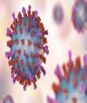综合应用

1. 翻译练习

1. 2020年初武汉发生了新冠肺炎疫情。

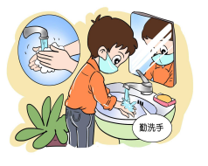

2.全国立刻行动起来抗击疫情，专家反对春节聚会，人们听从专家建议少聚集，戴口罩，勤洗手。

1. 大批医生护士签字报名支援武汉，成为最美逆行者，全国其它城市向武汉捐赠大批生活物资。
2. 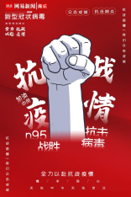这一切努力没有白费导致了疫情零增长，结果我们抗疫去的了阶段性成功。
3. 写作运用（尽可能的使用学习到的词汇或语块）

假设你是李华，你的美国好友Chris向你了解中国人抗击新冠肺炎做法，请用英语给他写一封邮件，告诉他你所知道的情况。主要内容包括：

1.感谢关心；

2.列举做法；

3.询问对方的近况。