**9年级英语第51课时 拓展任务**

**一、阅读文章，回答问题。**

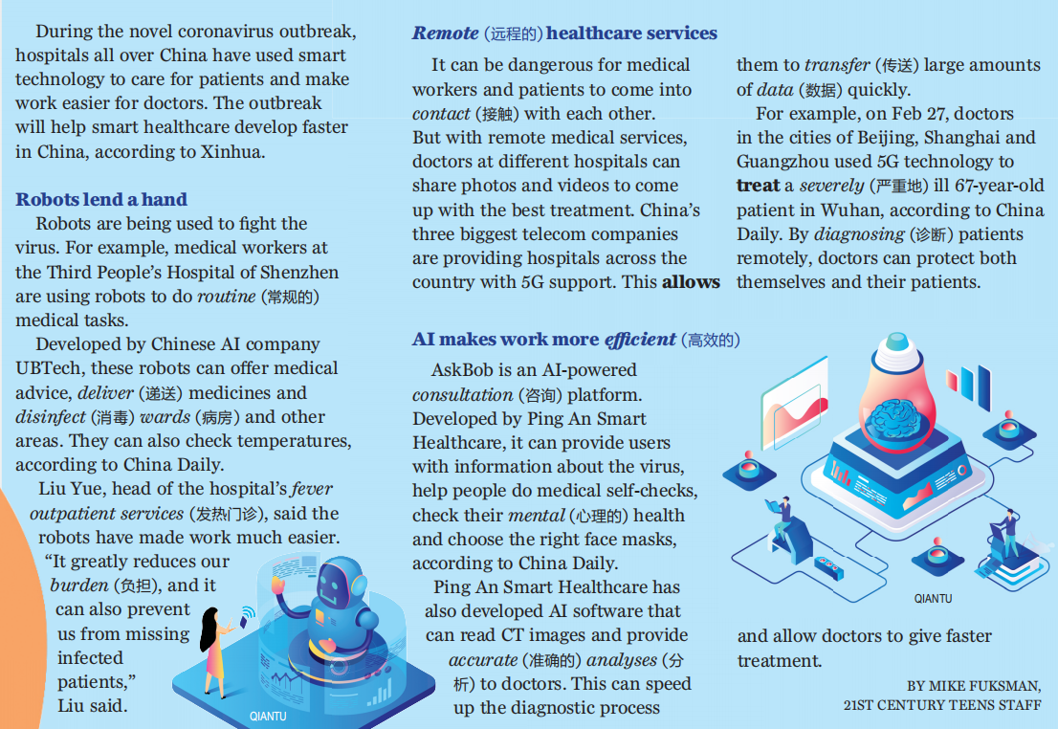

1. Which of the following is not mentioned?

A. Robots can deliver medicines. B. Robots can disinfect wards.

C. Robots can transfer patients. D. Robots can check temperature.

2. What happened to the severely ill 67-year-old patient in Wuhan?

A. He was treated remotely. B. He was treated by robots.

C. He was transferred to Beijing. D. He was not diagnosed with the virus.

3. The AI software developed by Ping An Smart Healthcare can help _____.

A. save treatment costs B. collect and transfer data

C. develop a vaccine D. reduce doctors’ burdens

4. The story is mainly about _____.

A. how smart technology is developing in China

B. why China was slow to control the epidemic

C. how smart technology helps doctors during the outbreak

D. which smart technologies are being developed in China

**二、积累词汇、短语和有用的表达。**