**9年级英语第51课时 学习指南**

**【学习目标】**

**在本节课结束的时候，我们能够：**

1. 通过略读和精读活动，分析文章结构,获取细节信息；

2. 完成整篇文章的思维导图，利用思维导图复述文章；

3. 结合已有知识，谈谈我们复课后应该如何做好防范。

**【学习任务单】**

**任务1、阅读文章，回答问题。**

**World takes caution**

As cases of the novel coronavirus (新冠病毒) continue to increase in more countries, the World Health Organization upgraded its coronavirus risk assessment (评定) to “very high” on Feb 28.

As of 12 pm on March 4, 74 countries outside of China had confirmed (确认) cases of COVID-19, according to WHO. The number of infections (感染) in South Korea had risen to 6,088 as of 4 pm on March 5, Xinhua reported. In Italy, a total of 3,144 people had tested positive (阳性) for the novel coronavirus, with 107 deaths, as of March 5. Denmark, Estonia, the Netherlands and Nigeria have all reported cases that have links to Italy.

“The continued increase in the number of cases, and the number of affected countries over the last few days, are clearly of concern (担忧),” said WHO Director-General Tedros.

Tedros called on countries to take action to contain the outbreak.

To share the most up-to-date COVID-19 control and prevention information, the Chinese Center for Disease Control and Prevention (CDC) has published a manual (手册) in both English and French. People and organizations can download it from the CDC website.

Progress is being made in developing vaccines (疫苗) and treatment methods. WHO said more than 20 vaccines are in development around the world, and several treatment methods are in clinical (临床) tests.

WHO said people can still take action to protect themselves, despite the lack of a vaccine.

“There are things every person can do to protect themselves and others today,” Tedros said. He stressed people should wash their hands regularly, clean surfaces regularly with disinfectant (消毒剂), avoid travelling with a fever or cough, cough or sneeze into clothing, and take extra precautions (警惕) if being over the age of 60.

1. Divide the article into 3 parts according to the headlines.

a. present situation of the disease  Para. ______________

b. actions that have been taken Para. ______________

c. suggestions on self- protection Para. ______________

1. What’s the structure of the first part?
2. Read the second part and answer questions.
3. What’s the meaning of **contain**?

______________________________________

1. What has China done to fight the disease?

______________________________________

1. What is the whole world doing to fight the disease?

______________________________________

1. Read the third part and underline the ways of self-protection.

**任务2、阅读文章，画出思维导图。**

1. Draw a mind map of the structure of the passage.

**任务3、阅读文章，回答问题。**

**What has China impressed the world with?**

Timely and transparent (透明的) information is important when dealing with epidemics (疫情). In the fight against the novel coronavirus, China has impressed the world with its fast response (应对), transparency and close cooperation (合作) with the international community.

After the epidemic broke out in China at the end of Dec 2019, the National Health Commission (国家卫生健康委员会) immediately sent an expert team to Wuhan, the center of the outbreak, for a deep investigation (调查). On Jan 8, the novel coronavirus was first identified (确认) as the cause of the epidemic. Three days later, China established a daily reporting system, updating the public every day. Both the central and local-level governments held daily news conferences, giving detailed numbers of new cases, deaths, patients in serious condition and recoveries.

At the same time, China has been sharing relevant information with the whole world in a transparent and responsible manner. Soon after China worked out the genome sequence (基因序列) of the new virus, itgave the results to the World Health Organization (WHO) so that other countries could use **it** to carry out research and develop medicine. China also provided WHO with a detailed paper about more than 44,000 confirmed cases, which offers “a better understanding about the age range of people affected, the severity (严重性) of the disease and the mortality rate (死亡率),” said WHO director-general Tedros Adhanom Ghebreyesus.

Meanwhile, efforts and support from around the world are also being welcomed to fight the disease. At the moment, a WHO team is working in China to find more methods to better treat and prevent the disease. “China has set a new standard (标准) for other countries to prevent and control the epidemic, while no other country has the scale (规模), speed, transparency and openness comparable (比得上的)to China, said Margaret Chan, former director-general of the WHO.

1. Which is the structure of the passage?

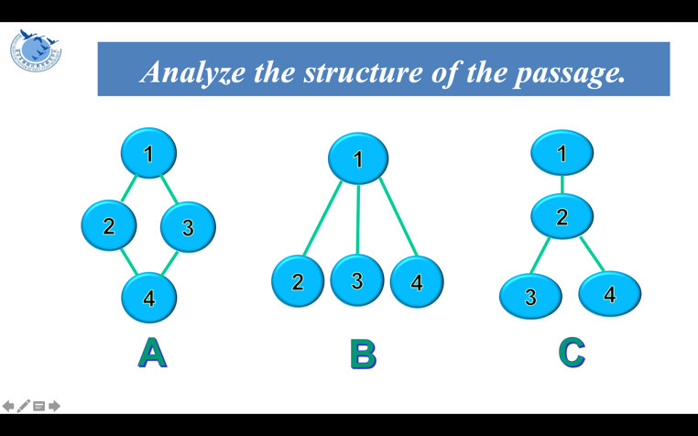

1. What does the underlined word “it” refer to?

A. WHO.

B. The genome sequence.

C. The new virus.

D. A detailed paper.

3. What can we infer from this paragraph?

A. China hasn’t followed WHO standards.

B. Other countries failed to respond to the epidemic.

C. China has set a good example for fighting the virus.

D. Other countries have done much better than China.

**任务4、阅读文章，画出思维导图。**