9年级英语第50课时 拓展任务
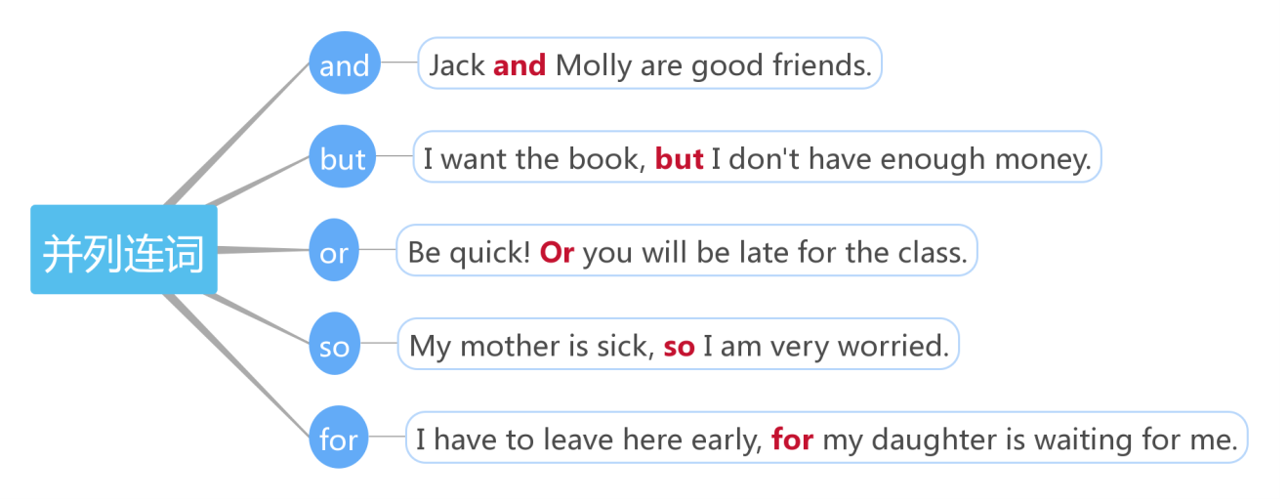
一、完善连词语法知识结构图。

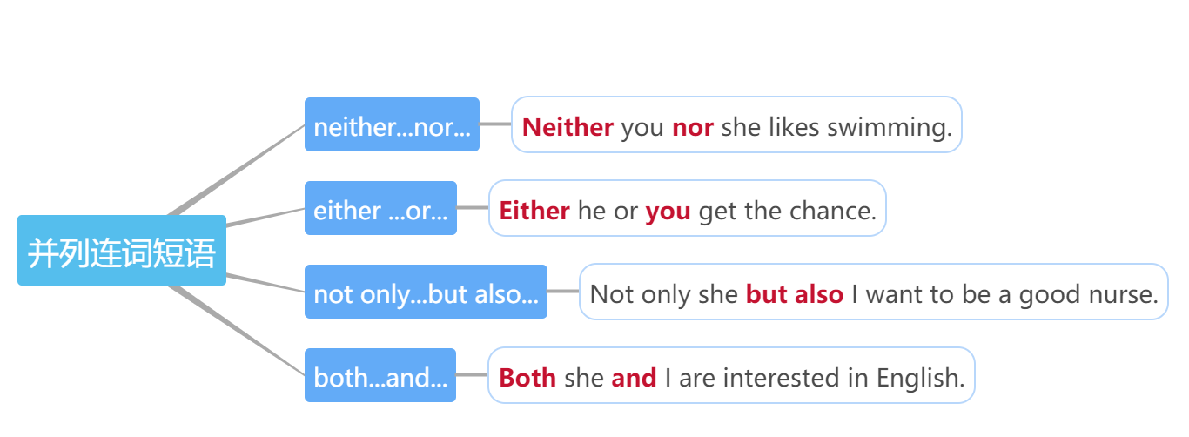

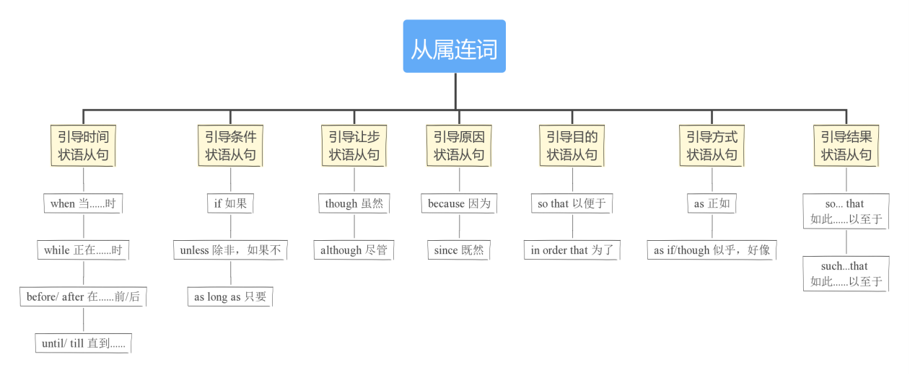

- 阅读文段，列举你找到的几种连词，并说明其作用。
2019中考阅读与表达
Within an hour, Marchenko and his team saw a wave that was about 13 feet high. The ship’s navigation (航行) system finally recorded the largest waves. They were more than 20 feet in height. The waves were so strong that they forced huge pieces of ice to jump up and down, breaking the ice into smaller pieces within just one hour. Scientists had never imagined that the process could happen so fast. The waves in these areas used to be small.

三、针对连词自拟单项选择题，并标注考查点和解题分析。

