高一年级英语第41课时“艺术”Masterpieces(1)

Lesson 1 Masterpieces （1）——学习任务单

【学习目标】

Learning objectives:

To read and talk about paintings and masterpieces

To read for general understanding

To read for specific information and understand words in context

To read for similarities between three different paintings

【学法指导】

阅读时，务必关注文章说明的细节：

1. 画作的内容，特点和画作背后的信息和所表达的画家的情感。

2. 对不同的画作进行描述并且能够比较三幅画作的异同。

Task One Answer the question :

What is masterpiece?

Task Two Read the text and find the details of each picture

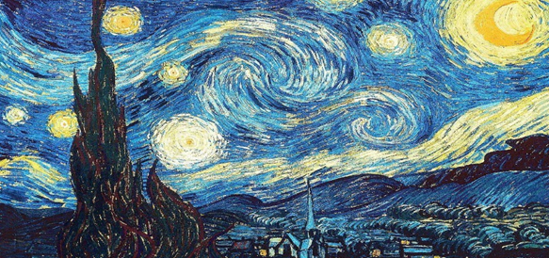

The Starry Night

What does the painting show?

What may have inspired the painter?

What did the artist think or say about the painting?

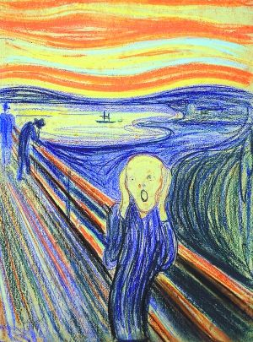

The Scream

What does the painting show?

What may have inspired the painter?

What did the artist think or say about the painting?

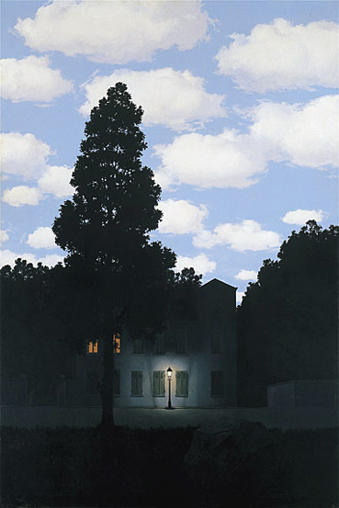

The Empire of Light

What does the painting show?

What may have inspired the painter?

What did the artist think or say about the painting?

Task Three Sort the expressions into the correct columns. Use them to practice introducing the paintings.

1.with an expression of fear

2 let out a powerful scream

3 circles of white and yellow racing across the sky

4 a burning orange-red sky

5 surrounded by the darkness of night

6 the night sky with clouds, stars and a moon

7 a beautiful house lit by lights from inside

8 full of brightness and soft white clouds

9 looks directly at the viewer

10 a sleeping village and a dark, lonely tree

|  |  |  |
| --- | --- | --- |
| ***The Starry Night*** | ***The Scream*** | ***The Empire of Light*** |
|  |  |  |