**话题：人与自然《环境保护》Reading(1)学法指导**

**[学习目标]**

1. **获取和梳理说明文提到的全球现象；全球变暖现象背后的原因；以及科学家对其所持有 的不同的观点态度。**
2. **概括说明文的文体结构、语言特点；**
3. **基于所读文本内容发表自己对全球变暖的观点。**
4. **联系个人生活，交流探讨对于全球变暖是否应该做些什么，提出应对的建议。**

**[学法指导]**

1. 通过Skim /scanning/draw mind map 等方法去梳理文中说明的现象、背后的原因以及不同科学家所持有的态度；
2. 通过看文中的两个图标分析全球变暖产生的根本原因并总结如果读取图标的信息；
3. 通过获取不同科学家对全球变暖持有的不同态度，学会辩证的去看待这一现象带来的后果；
4. 通过所梳理的信息联系个人生活实际对文章标题的后半部分进行思维拓展，对于如何应对该现象联系生活实际提出应对建议；

**Task 1 Read Para 2-5 and finish the following tasks.**

1. **What has caused the global warming? why?**
2. **Who was mentioned to explain it?Draw a mind map and try to describe how he explained it.**
3. **Learn to explain what the 2 graphs show?Why they were used?**

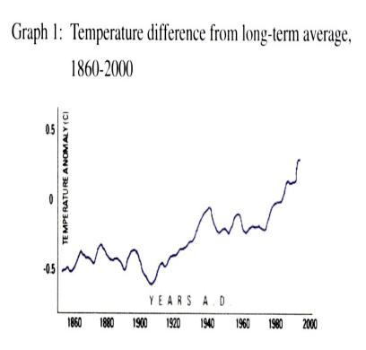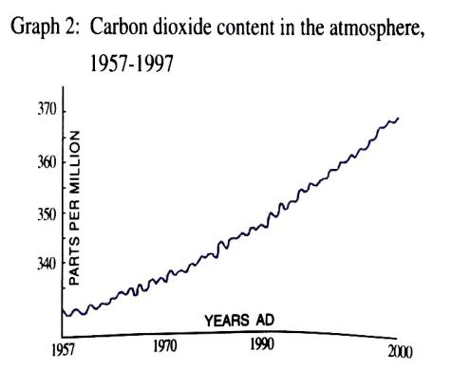

**From Graph 1, we can see ________________________________________________________**

**From Graph 2, we can see ________________________________________________________**

1. **What are the opinions of Dr Janice Foster according to graph2?**

**Part 2 Read the rest part of the passage and finish the following tasks.**

**Task 1 Answer questions**

**1. which two scientist are mentioned here?**

**2. Do they agree with each other?If not, what's their opinions?**

**3.What is the writer’s attitude towards the effects of global warming?How do you know?**

**Task 2 choose the best answer**

1. **What is the writer’s attitude towards the effects of global warming?**
2. **positive B. objective C. negative**
3. **The author probably agrees that ______**

**A .actually global warming is good for man.**

**B. we should do nothing about the global warming.**

**C. catastrophes will happen if the globe keeps on warming.**

**D. a lot remains to be found out about the effects of global warming.**

**3. What methods did the writer use to make his argument more convincing ?**

**Task 3. show your attitude**

**Make a dialogue by using the following sentence patterns**

1. **S1: I subscribe to (agree with) Dr. Foster’s point of view. On the one hand, …. On the other hand….**
2. **S2: I’m afraid I disagree with you. (I’m afraid not. / I don’t think so. / I doubt …)**

**Task 3 Let’s make a difference to the global warming**

1. **Global warming May be a big problem, but there are many things we can do to make a difference. Think about how to do it?**

**2.homework**

**最近你的英国笔友Mike 想改变自己的生活方式，低碳生活为保护环境出份力，但不知道该从何做起，写信向你寻求建议，请你给他写封回信发表自己对他这样作的看法并提出建议。**

**1. 不用灯的时候及时关灯；**

**2. 尽量绿色出行；**

**3....**