**话题：人与自然《灾难防范》Grammar**

**[学习目标]**

Revise the *–ing* form as an adverbial

Distinguish the *–ing* form and the perfect *–ing* form

Try to use the *–ing* form and the perfect *–ing* form properly

**[学法指导]** 学生回忆课文，回答问题，发现现在分词一般式与完成式的区别，在不同的情境（句子、篇章与写作任务）中练习与巩固语法知识。

**Task 1: Read, think and discover**

1. Read the text again and answer the questions.

When did the writer start working as a volcanologist?

How does the writer feel about his /her work?

1. Examine the sentences and tell in what way the structures are similar to each other and in what way they are different.

I was appointed as a volcanologist working for the Hawaiian Volcano Observatory (HVO) twenty years ago.

Having studied volcanoes now for many years, I am still amazed at their beauty as well as their potential to cause great damage.

1. Underline the sentences from the reading passage with the perfect *–ing* form.

Having collected and evaluated the information, I help other scientists to predict where lava from the volcano will flow next and how fast.

Having worked hard all day, I went to bed early.

Having experienced quite a few earthquakes in Hawaii already, I didn’t take much notice.

Having earlier collected special clothes from the observatory, we put them on before we went any closer.

**Task 2: Exercise**

1. Complete the sentences using the *–ing* form or the perfect *–ing* form and tell their usages.

1). As I came out of my house, I saw the volcano erupting.

_______ out of my house, I saw the volcano erupting.

2). Because she didn’t know what to do, she turned to me for help.

____ ________ what to do, she turned to me for help.

3). The children started for London, and they sang and laughed.

The children started for London, ______ _____ _______.

4). The factory keeps giving off smoke. As a result, the air is made dirty.

The factory keeps giving off smoke, ______ the air dirty.

5). If we prepare fully, we can achieve great things.

_________ fully, we can achieve great things.

6). Though he has lived in Canada for three years, he can’t speak English well.

______ ______ _____in Canada for three years, he can’t speak English well.

1. Combine the pairs of sentences into one, using the *–ing* form or the perfect *–ing* form.

1). Tim was feeling exhausted. He went to bed as soon as he got home.

______________________________________________________

2). I swallowed the nuts too quickly. I began to cough.

______________________________________________________

3). John watched the volcano erupt. He became worried about his safety.

______________________________________________________

4). I am very clumsy. I tripped and broke my cell phone.

______________________________________________________

5). I gathered all my courage. I ran back into the burning house to rescue the baby.

___________________________________________________________

___________________________________________________________

6). I guaranteed that we would get there before five. I panicked when the car broke down.

________________________________________________________

________________________________________________________

7). I opened a strange e-mail attachment yesterday. I started having computer problems. ________________________________________________________ ________________________________________________________

8). Because he had been trapped in traffic, he was late for work.

______________________________________________________

1. Complete the passages using the correct form of the words given in the brackets.

1)______(be) a curious person, I once decided to search the Web for my own name. Not many search results came up, but one labeled “geeks” caught my eye. ________(look) at the site, I almost died! It was my face – a classmate __________ (post) it! I e-mailed the websites, and they took it off the next day.

2)_________________(complete) a 20-page story for my creative writing class, I clicked “print”. Well, my computer crashed _______(print) the first page! Finally at 10 P.M., ___________(try) everything to fix the computer, I started rewriting the story – by hand. It took me most of the night!

3)An eyewitness account of a murder at Flat 3, Southampton Gardens, London

________ (arrive) at the party, I found all my friends were already there. The dancing was just beginning.__________ (stand), I saw some of my friends chatting at a table. So I went over to join them. All this while I had not seen my hostess.___________ (take) a drink, I ____(feel) rather uncomfortable and got a headache. A maid took me upstairs to rest. It was about 10 pm. ___________ (rest) for a while, I felt better and went to the balcony to have some fresh air. It was at that moment that I realized something was wrong. _______ (hear) a scream, I rushed downstairs only to see my hostess lying unconscious on the floor, surrounded by her guests. She ________(shoot).

1. Rewrite the description of the pictures using the *–ing* form or the perfect *– ing* form.

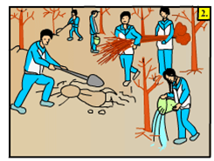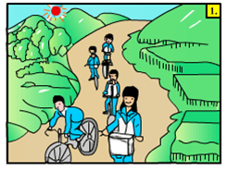

Early in the morning, we rode to the suburbs, and enjoyed the beautiful view along the way.

________________________________________________________________________________

When we arrived there, we began to work. Everyone had their hands full, some were digging the holes, some were carrying the young trees, while others were planting and watering them.

__________________________________________________________________________________

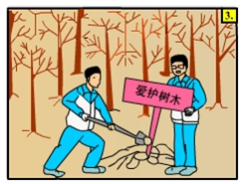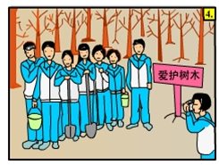

After we had planted all the trees, We put up a board to remind people to protect the trees.

_________________________________________________________________________________

At last, we took a picture in front of the trees， because we hope to record this great memory in our lives.

__________________________________________________________________________________

1. 假设你是红星中学学生李华，上周参加了学校组织的“京郊美丽乡村”展示活动，为此，你与父母一起去感受了乡村的变化。

