**Gramma 名词性从句 (2)+词缀**

**【学习目标】**

1. 总结梳理名词性从句中主语从句、宾语从句和表语从句的用法；

2. 学习常见的添加前后缀的构词法，扩展词汇量。

**名词性从句总结**

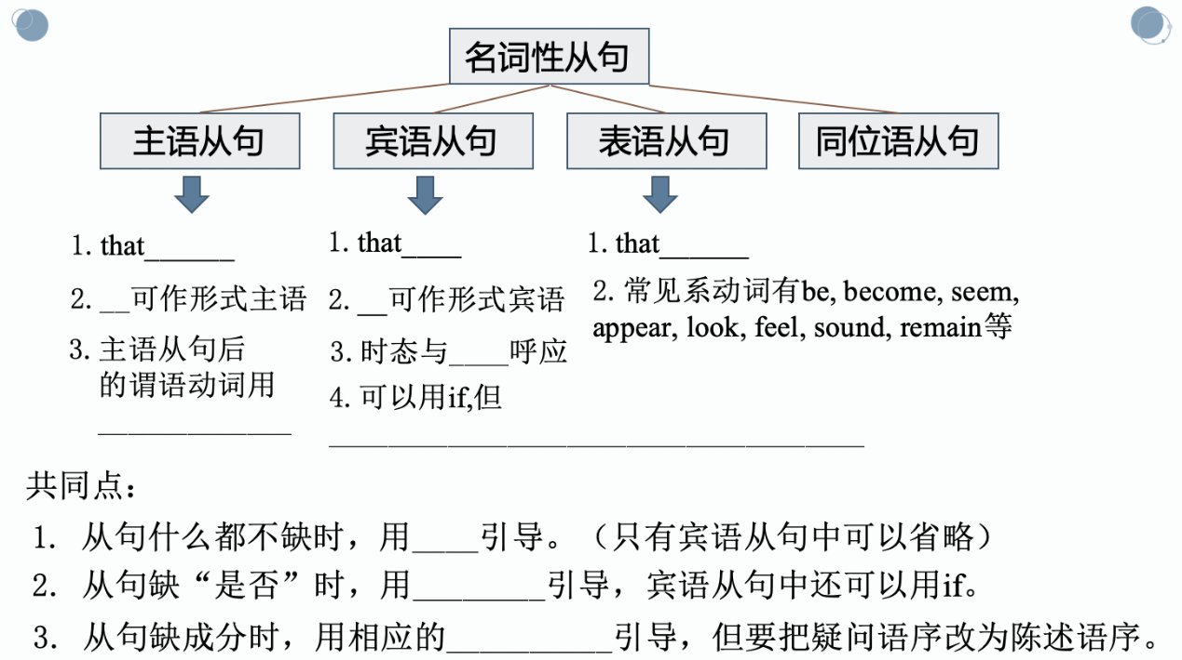

**Page 8-9 Lesson 1**

1. Van Gogh painted what he saw from his window. 宾语从句

2. His unusual use of colour has led experts to think that Van Gogh’s mental illness may have affected his sense of sight. 宾语从句

3. He also thought *The Starry Night* was a failure. 宾语从句

4. However, the fact remains that *The Starry Night* is now one of the world’s most famous paintings. 表语从句

5. What makes it striking is *that* it shows a thin figure with an expression of fear. 主语从句、表语从句

6. In his diary, Munch talked about what inspired him. 宾语从句

7. Many experts say that *The Scream* is connected to Munch’s mental health problems, ... 宾语从句

8. What is strange is that above the house and the tree, we see a daytime sky full of brightness… 主语从句、表语从句

9. His view was that art should shock the viewers and challenge their sense of reality. 表语从句

10. Some feel that the paintings look dark and troubling. 表语从句

11. …, he thought that the change between day and night in the paintings was surprising. 宾语从句

**用正确的连接词填空**

Holidays are important for all of us. 1. ________ we decide to have a city holiday or a holiday by the beach depends upon our personal preferences. The main thing is 2. ________ we are taking a break from our usual routine.

Of course, the main difference between city holidays and beach holidays is in the kind of activities you are able to do. At the beach, for example, you can swim or surf. While in a city, 3. _______ you can do varies from going shopping to visiting museums and going to the theatre.

Another major difference is 4. ________ having a holiday by the beach tends to be more relaxing. When you are in a city, you have to organize 5. ________ you do carefully, or the fact that you spend all your time getting on buses, walking and visiting may make you get exhausted soon.

On the other hand, the beach is 6. ________ time goes by more slowly. If you like, you can swim, lie in the sun or the shade, have a quiet drink and go to sleep.

All in all, 7. ________ you go to spend a holiday largely depends on 8. ________ you like and how hard you have been working.

**添加前后缀构词**

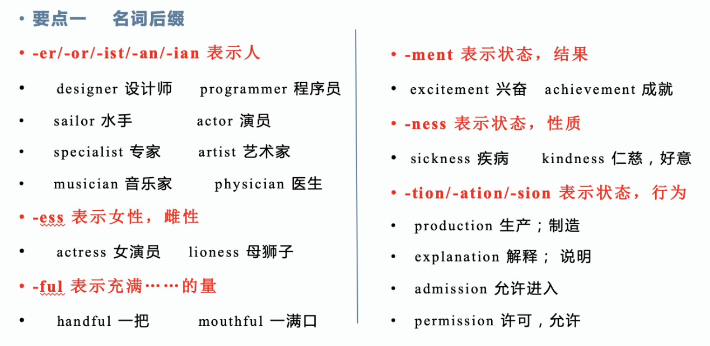

**练习：**

1.The Sunday papers are full of （advertise） for cars.

2.This （perform） will begin at 8：00 pm this Sunday.

3.What is John’s （react）when you told him the news.

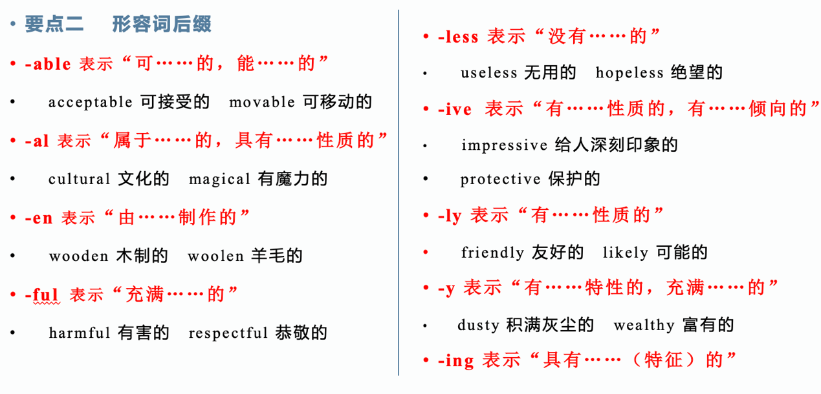

**练习：**

1. She was rescued from a 　　 （burn） building.

2. His voice sounded 　 　 　 　 （threaten）.

3. The player’s 　 　 　 　 　 performance in the Olympics made us　 　 　 　 　 （disappoint）.

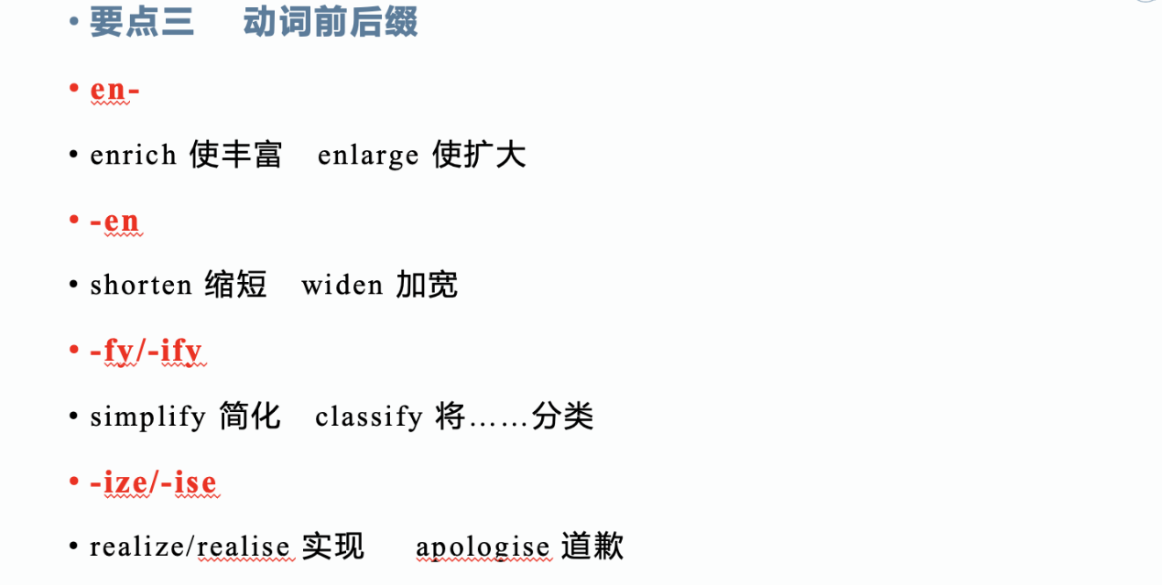

**练习：**

1. I’d like to work abroad to （broad） my horizons.

2. I think you should （apology） to your brother for losing your temper.

3. I think through this activity （large） our eyes.

**Page 17 Complete the Word Builder.**

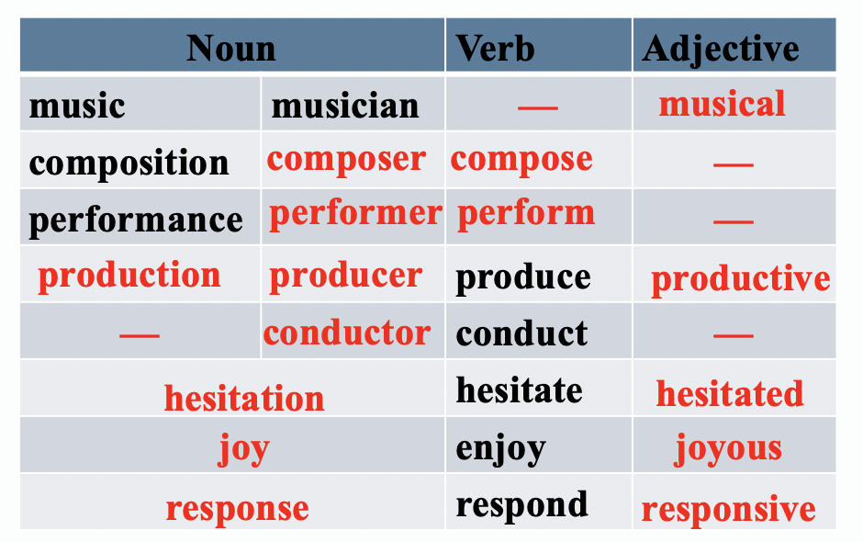

**Page 17 Complete the sentences in the correct form of the words in the Word Builder.**

1. It has always been my dream to ________ an orchestra.

2. The musician _________ with nervousness before he began to play.

3. Beethoven is recognised as a _________ genius by people around the world.

4. Beethoven is the __________ of Symphony No. 9 in D minor.

5. To his mother’s _____, he won first prize.

6. She told me about the wonderful ____________ that she had been to last week.

7. The audience’s ________ to the performance of the symphony was extraordinary.

8. Though Beethoven lost his hearing, he _________ some amazing pieces of music.