9年级英语第48课时 学习指南

【学习目标】
本节课结束时，我们能够：
1. 梳理阅读B篇解题方法，迅速精准定位答案，完成语篇阅读；
2. 整合阅读B篇实词，对比上下文搭配并挖空，完成完形，并积累语篇词汇。

【学习指南】
2019年北京市中考B篇
Blue Lightning
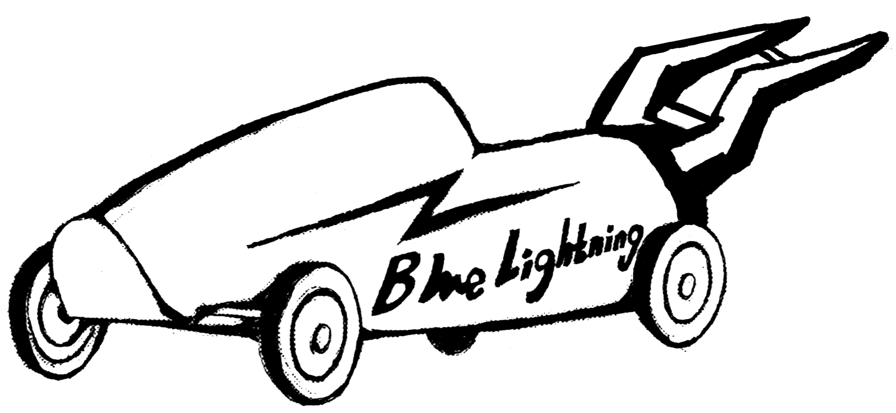
Sally loved cars more than anything else. This spring she thought of building a go-kart to enter for the Go-Go Race. So she asked her dad for help.
go-kart

“Well,” he said. “How about this: you do some research first and then come back to me with a design.”
A week later, Sally brought her notes and drawings to Dad. She named her go-kart “Blue Lightning”. Dad looked over her work, thinking. “Well, that’s interesting,” he said. “Have a try. Just build Blue Lightning as you’ve designed.”
Over three weekends of hard work, Sally turned her design into a real, working go-kart and painted it light blue. Dad asked her to take it for a test drive. Sally agreed.
After she did that, Sally drove back to Dad. “Well,” she said. “Now I know why you wanted me to have a test drive.”
“Oh, do you?” he said. “Please share.”
“When I drove fast, there was a lot of pushback,” she said. “I think it’s because of the lightning bolt (闪电) shape.”
“Very good!” Dad said.
“So, why didn’t you tell me about that problem in the first place?” Sally asked.
Dad laughed. “Where’s the fun in that? If you give a man a fish, he’ll eat for a day. But if you teach a man to fish, he’ll eat for a lifetime.”
Sally said, “I see. Anyway, designing is half the fun!”
Dad smiled. “Good. Sometimes, learning happens during the process. We learn how to do something right by doing it a few times first and making mistakes along the way.”
That encouraged Sally and she worked even harder. When she showed Dad her new go-kart, he nodded with pride.
Finally came the race. Sally wasn’t worried about whether she would win—in her mind, she had already won, by building something better than ever before.

1．Sally thought of building a go-kart to ______.
A. practice driving B. enter for a race
C. play with friends D. do some research

2．What did Sally’s dad ask her to do after she built the go-kart?
A. To have a test drive. B. To take a good rest.
C. To give it a cool name. D. To paint it light blue.

3．Sally’s story mainly tells us that ______.
A. winning a race is important
B. fishing brings us a lot of fun
C. driving experience is necessary
D. learning happens during the process

阅读B篇的解题策略____________________________________________________
____________________________________________________
____________________________________________________
____________________________________________________
____________________________________________________

实战练习：请同学们完成2018年中考B篇
2018年北京市中考B篇
A Beautiful Moment
When I was in high school, I worked part-time helping Dad sell fruits and vegetables at a market. One day, as I was preparing the fruits, a little boy came by with his mom and sister. He was about eight years old, and the girl, five or six. They were looking the fruits in front of me. I heard the kids say to their mom (in French), “They’re good!” I knew it was French, because I can speak and understand it.
Then I noticed how the mom was picking the fruits. At first I thought she was really looking at the fruits because she was facing them, but then I noticed how much she had to feel and smell each one as she picked them out. And she often asked her son if it looked okay, but looked way above where his face was. Putting what I saw together, I was sure she was blind.
Both of the kids continued to help their mom pick out the fruits. The son made sure the fruits were not obviously bad, and the daughter handed them to her mom. The woman then felt each one and smiled, and the daughter would put them into their basket. The kids were smiling while helping their mom pick the fruits out.
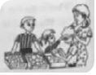
Their smile and gentle manner moved me in a way that never happened before. It was so beautiful to see such young kids so willingly help. Most kids that age would be picking out candies or toys in a store for themselves, instead of helping their mom pick out fruits, as the two kids did.
It was great to witness the moment, but not so great because I didn’t tell the mom how beautiful her children were in their language. This is what I regret to this day.

（ ）1. The women and her kids came to the market to buy .
A. fruits B. vegetables
C. candies D. toys
（ ）2. According to what he saw, the writer was sure the mother couldn't .
A. speak B. see C. smell D. hear
（ ）3. The writer was moved because .
A. the mother was brave to face her problems
B. the kids were polite and kind to each other
C. the mother was careful in picking out things
D. the kids were so willing to help their mother

助力完形：通读文本，回顾B篇，对比选项，回填空白
2019年北京市中考B篇
Blue Lightning
Sally loved cars more than anything else. This spring she thought of building a go-kart to enter for the Go-Go Race. So she asked her dad for help.
go-kart

“Well,” he said. “How about this: you do some research first and then come back to me with a 1 .”
A week later, Sally brought her notes and drawings to Dad. She 2 her go-kart “Blue Lightning”. Dad looked over her work, thinking. “Well, that’s interesting,” he said. “Have a try. Just build Blue Lightning as you’ve designed.”
Over three weekends of hard work, Sally turned her design into a 3 , working go-kart and painted it light blue. Dad asked her to take it for a test drive. Sally agreed.
After she did that, Sally drove back to Dad. “Well,” she said. “Now I know why you wanted me to have a test drive.”
“Oh, do you?” he said. “Please 4 .”
“When I drove fast, there was a lot of pushback,” she said. “I think it’s because of the lightning bolt (闪电) shape.”
“Very good!” Dad said.
“So, why didn’t you 5 me about that problem in the first place?” Sally asked.
Dad laughed. “Where’s the fun in that? If you give a man a fish, he’ll eat for a day. But if you 6 a man to fish, he’ll eat for a lifetime.”
Sally said, “I see. Anyway, designing is half the fun!”
Dad smiled. “Good. Sometimes, learning happens during the process. We learn how to do something 7 by doing it a few times first and making mistakes along the way.”
That encouraged Sally and she worked even harder. When she showed Dad her new go-kart, he nodded with 8 .
Finally came the race. Sally wasn’t worried about whether she would win—in her mind, she had already won, by building something better than ever before.

（ ）1. A. drawing B. design C. painting D. work
（ ）2. A. named B. marked C. called D. hold
（ ）3. A. interesting B. beautiful C. real D. new
（ ）4. A. go B. introduce C. explain D share
（ ）5. A. tell B. say C. talk D. speak
（ ）6. A. ask B. teach C. want D. order
（ ）7. A. funny B. useful C. cool D. right
（ ）8. A. smile B. discouragement C. pride D. anger

