9年级英语第47课时 学习指南

【学习目标】
在本节课结束时，我们能够：
1.能够通过完形填空的标题和图片，预测文章内容。
2.能够通过完形填空的首段和尾段，了解文章主要内容。
3.能够通过事件发展顺序以及作者情感变化，梳理文章内容。
【学习任务单一】
任务1：关注文章标题及图片，预测文章内容
Run for Class President
Two months ago, when our class election (选举) started, I decided to run for class president. I enjoyed speaking in public and got along well with people, so I felt it easy to win. But I was $13$ that people would feel bad for me if I lost.
What is the story about？
_______________________________________________________

任务2：抓住首尾，了解短文
Two months ago, when our class election (选举) started, I decided to run for class president. I enjoyed speaking in public and got along well with people, so I felt it easy to win. But I was $13$ that people would feel bad for me if I lost.
1.What did the writer think of his running for the class president? Why?
__________________________________________________________________
2.Would the writer win the election?
___________________________________________________________________
I don’t regret putting time and energy into the election because I’ve learned that things aren’t always going the way I expect. And moments of failure like this build 20 —since then I’ve learned to face disappointment and grown stronger.
- Did the writer win ? How do you know that?
___________________________________________________________________
2.What does the writer think of his failure?
___________________________________________________________________

任务3:通读全文，把握脉络

Run for Class President
Two months ago, when our class election (选举) started, I decided to run for class president. I enjoyed speaking in public and got along well with people, so I felt it easy to win. But I was $13$ that people would feel bad for me if I lost.
I was busy preparing in the following week. My plan wasn’t to make promises to do things I couldn’t 14 but to show my class why I wanted to be president. I put up my posters in hallways and in the classroom. I also spent three hours writing my speech, saying that I was the one they could turn to whenever they had a problem. Since I was 15 prepared, I felt that my chances of winning were strong.
However, when I gave my speech on Election Day, the response (反应) wasn’t what I had 16 . Few people actually listened. When it was my opponent’s (对手的) turn, everyone was screaming his name. His speech was short, but all to the point. By then, I realized I should have made mine shorter and clearer.
It was obvious who would 17 . For the rest of the day, I felt like it was over. I wanted to just go home and cry, but I made it through.
My 18 was right: I didn’t win.
The next day, people were still talking about the election. I just pretended (假装) not to hear. But later, things got better. People 19 about the election and talked to me just as they did before.
I don’t regret putting time and energy into the election because I’ve learned that things aren’t always going the way I expect. And moments of failure like this build 20 —since then I’ve learned to face disappointment and grown stronger.

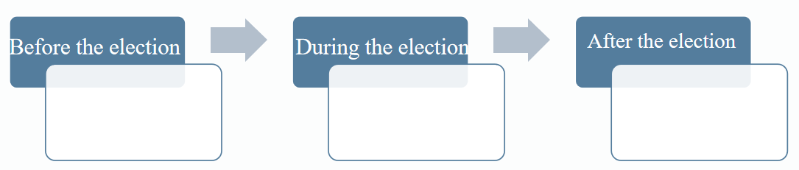
任务4：瞻前顾后，上下求索
13．A．bored B．afraid C．excited D．hopeful
14．A．compare B．remember C．manage D．repeat
15．A．fully B．quickly C．freshly D．physically
16．A．feared B．faced C．mentioned D．pictured
17．A．insist B．return C．wait D．win
18．A．suggestion B．prediction C．direction D．introduction
19．A．forgot B．wrote C．cared D．discussed
20．A．trust B．pride C．character D．support

【学习任务单二】
任务1：关注文章图片，预测文章内容
- Where is the man ?

- What is the weather like on that day?

- Can you guess the man’s feeling?
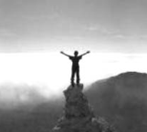

任务2：抓住首尾，了解短文
Before my trip to the mountains, I used to be a homebody. I felt completely__13 spending weeks or even months—in my hometown or sometimes even on my block—without going anywhere.I could be quite satisfied by watching the Discovery and National Geographic Channels.

The next day we returned—my 20 started to hurt so badly that I could hardly walk. But every time I felt an ache, I remembered the feeling of being high above, with my head touching the skies and the clouds swimming below.

- What made the writer change his attitude

任务3: 通读全文，把握脉络
Before my trip to the mountains, I used to be a homebody. I felt completely__13 spending weeks or even months—in my hometown or sometimes even on my block—without going anywhere. I could be quite satisfied by watching the Discovery and National Geographic Channels.
The situation 14 when one day David, my best friend, rushed into my room and talked me into joining him on his journey to the Rocky Mountains. We set off five days later.
This was my first time in the mountains. 15 ,the weather was foggy most of the time, and the higher we got into the mountains, the less clearly we could see. On the first day, we were making our way along the foothills; but the next day, we started to climb on one of the peaks（山顶). 16 it was not that straight and high, I was still excited. I regularly speeded up, and because of that I ran out of 17 long before we got to the top.
When we finally got there, nothing had really changed. The same fog was nearly covering everything. I felt so disappointed, because I had, during the whole course of climbing, 18 to see the view from above and perhaps to be able to take some photos. We spent a couple of hours on the top, and decided to turn back, when the wind suddenly 19 the clouds, and the place we were standing on was brightened with the sun. I saw a fantastic panorama(全景图）in front of me, and for some moments I couldn't believe my eyes. It was so amazing that I realized I couldn't help looking forward to the next trip to the mountains.
The next day we returned—my 20 started to hurt so badly that I could hardly walk. But every time I felt an ache, I remembered the feeling of being high above, with my head touching the skies and the clouds swimming below.

作者情感变化
事件发展顺序

任务4：瞻前顾后，上下求索

13. | stressed | B.comfortable | C.bored | D.strange
14. | A.changed | B.remained | C.worsened | D.repeated
15. | A.Undoubtedly | B.Immediately | C.Unfortunately | D.Unnaturally
16. | A.When | B.Because | C.Since | D.Though
17. | A.money | B.patience | C.energy | D.time
18. | A.expected | B.managed | C.offered | D.learned
19. | A.shaped | B.joined | C.cleared | D.thickened
20. | A.arms | B.legs | C.hands | D.eyes

