**9年级英语第45课时 学习指南**

**【学习目标】**

在本节课结束后，希望同学们能够：

1. 通过听后选择题的训练，捕捉听力材料中事实性细节信息，并对其梳理分析，提升推理判断和归纳分析的能力；

2. 通过听后回答题的训练，提取并表达听力材料中的相关信息，提升沟通关键信息的能力。

**【学习任务单】**

一、听后选择

请听一段对话，完成第1至第2小题。

1. When is the holiday?

A. On the 3rd Sunday of July.

B. On the 3rd Sunday of June.

C. On the 3rd Saturday of July.

2. How do people celebrate the holiday?

A. By making ice cream.

B. By eating ice cream all day.

C. By having ice cream parties.

请听一段对话，完成第3至第4小题。

3. What is wrong with the boy?

A. He has a headache.

B. He feels stressed out.

C. He doesn’t like school.

4. What will the boy do?

A. Ask his parents for help.

B. Talk to his teacher.

C. Go to see a doctor.

请听一段对话，完成第5至第6小题。

5. Why doesn’t the girl want to visit the history museum?

A. Because she’s been there many times.

B. Because she isn’t good at history.

C. Because she thinks it’s boring.

6. Where are the speakers going?

A. To the art museum.

B. To the silk museum.

C. To the science museum.

请听一段对话，完成第7至第8小题。

7. What does the boy think of smart speakers?

A. Expensive. B. Convenient. C. Popular.

8. What are the speakers mainly talking about?

A. Types and usages of smart speakers.

B. The history and future of smart speakers.

C. Advantages and disadvantages of smart speakers.

请听一段独白，完成第9至第10小题。

9. Which is the common pattern of Chinese Paper Cut Art?

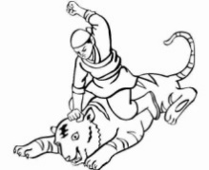 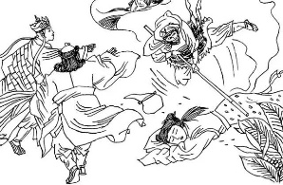 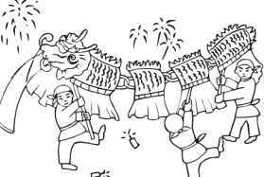

A. B. C.

10. Why does the speaker make the speech?

A. To tell people how to do paper cutting.

B. To introduce traditional Chinese art forms.

C. To show the beauty in Chinese Paper Cut Art.

听后选择题小结：________________________________________________________________

_______________________________________________________________________________

二、听后回答

请听一段对话，完成第11小题。

11. Where were the plates made?

_________________________________________________________

请听一段对话，完成第12小题。

12. What time did the club use to meet every Friday afternoon?

_________________________________________________________

请听一段对话，完成第13小题。

13. How can the girl get to the Capital Museum?

_________________________________________________________

请听一段对话，完成第14小题。

14. Why does the girl want to borrow money?

_________________________________________________________

请听一段对话，完成第15小题。

15. What will the boy do?

_________________________________________________________

听后回答题小结：________________________________________________________________

_______________________________________________________________________________