9年级英语第43课时 学习指南

【学习目标】

1. 在完形填空的尾段找出显性的作者写作意图（**aim/value**）

2. 使用流程图分析完形填空的文本，理解文本的深层含义

3. 在分析文本的基础上，提炼隐性的作者写作意图

4. 通过实战演练，体会读懂写作意图对正确理解文本的意义

【学习任务单】

[任务1] 找出或提炼近三年北京市中考英语完形填空的作者写作意图（**aim/value**）。

|  |
| --- |
| **2019年中考完形---**  **Run for Class President**  Two months ago, when our class election (选举) started, I decided to run for class president. I enjoyed speaking in public and got along well with people, so I felt it easy to win. But I was 13 that people would feel bad for me if I lost.  …  男 终I don’t regret putting time and energy into the election because I’ve learned that things aren’t always going the way I expect. And moments of failure like this build 20 —since then I’ve learned to face disappointment and grown stronger.  **The Aim / Value:** |

|  |
| --- |
| **2018年中考完形---**  **Real Solutions (解决方法) to Problems**  Thirty engineers were working as a team in a company. They were young and eager to learn. The management decided to teach them about finding real solutions to problems.  …  The manager announced this was the real solution to the problem. Many times in our life, sharing and helping others give us real solutions to problems.  **The Aim / Value:** |

|  |
| --- |
| **2017年中考完形---**  **A Meaningful Gift**  Emily was an eighth grader. To pass her Civics course(公民课程), she had to do some volunteer service in a nursing home for a week.  …  Emily 39 opened the box and was surprised to see what was inside. “It’s the bracelet that you wore. Thank you!”Emily said, with tears in her eyes. “I’m sure to visit you whenever I’m free.”  On her way home, Emily thought of her own love for the performing arts. She touched the bracelet and made a 40 that she would keep her word to Mrs. Blair.  **The Aim / Value:** |

[任务2]分析文章结构，理解深层含义，读懂写作意图（**aim/value**）。

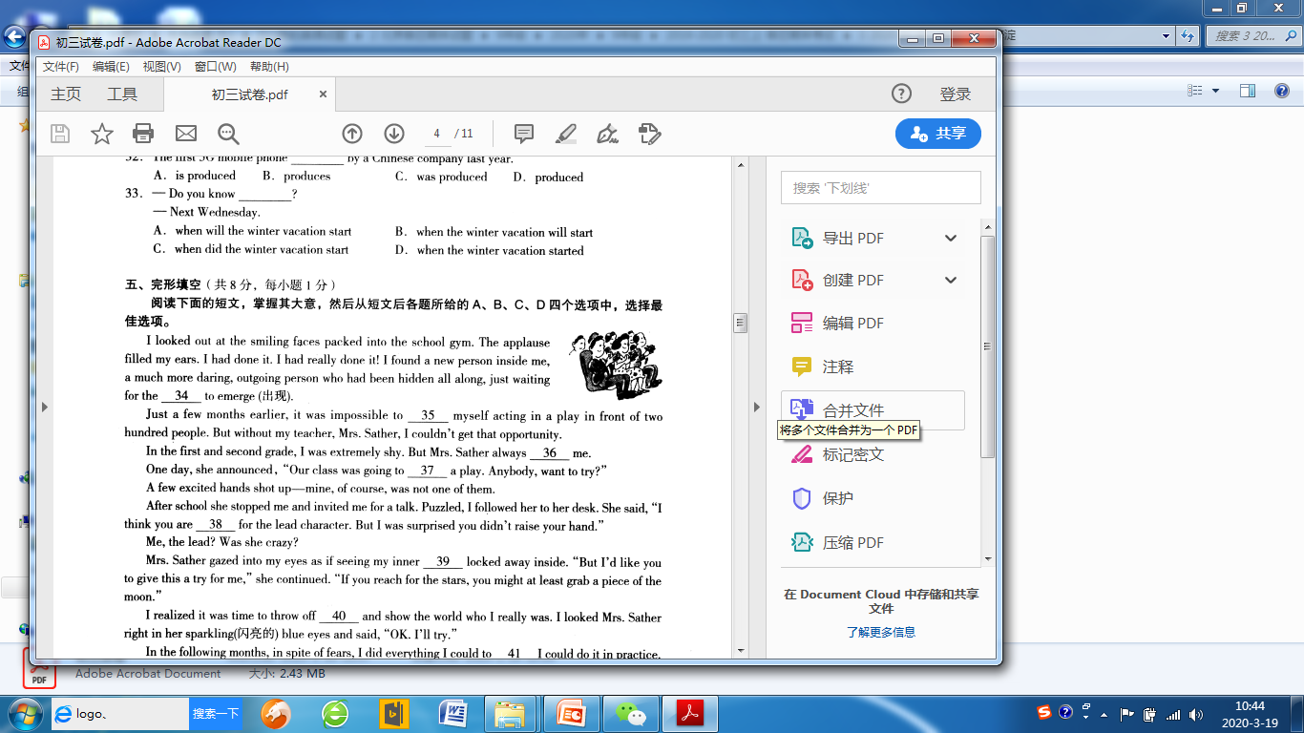完形填空（选自海淀区2019-2020学年第一学期九年级期末英语试题）  
 I looked out at the smiling faces packed into the school gym. The applause filled my ears. I had done it! I had really done it! I found a new person inside of me, a much more daring, outgoing person who had been hidden all long, just waiting for the 34 to emerge (出现).  
 Just a few months earlier, it was impossible to 35 myself acting in a play in front of two hundred people. But without my teacher, Mrs. Sather, I couldn’t get that opportunity.  
 In the first and second grade, I was extremely shy. But Mrs. Sather always 36 me.

One day, she announced, “Our class was going to 37 a play. Anybody, want to try?”

A few excited hands shot up—mine, of course, was not one of them.

After school she stopped me and invited me for a talk. Puzzled, I followed her to her desk. She said, “I think you are 38 for the lead character. But I was surprised you didn’t raise your hand.”

Me, the lead? Was she crazy?

Mrs. Sather gazed into my eyes as if seeing my inner 39 locked away inside. “But I’d like you to give this a try for me,” she continued. “If you reach for the stars, you might at least grab of the moon.”

I realized it was time to throw off 40 and show the world who I really was. I looked Mrs. Sather right in her sparkling (闪亮的) blue eyes and said, “OK. I’ll try.”

In the following months, in spite of fears, I did everything I could do to 41 I could do it in practice.

At the end of the play, when the audience applauded, I knew they were not just cheering for my performance that night, but for the performances they knew would come in later years because of my newfound confidence.

34. A. hero B. reason C. director D. opportunity  
35. A. watch B. mind C. imagine D. remember  
36. A. praised   B. reminded C. comforted D. encouraged  
37. A. perform B. write C. follow D. review  
38. A. famous  B. perfect C. responsible D. thankful  
39. A. ability B. self C. beauty D. peace  
40. A. pride B. patience C. shyness D. guard  
41. A. prove B. discover  C. expect D. test

|  |
| --- |
| **文本分析步骤：**  ***Step 1--List the events***  ***Step 2 -- Put the events into the flow map***  ***Step 3 -- What was “I” like in the events?***  ***Step 4 -- The value the author intends to convey*** |

[任务3] 基于文本分析和作者意图(**Aim/Value**)，选择各题的正确选项，将答案写在题号前。

[任务4] 实战演练

具体任务： 1. 使用流程图分析大兴区期末完形填空的文章结构

2. 找出或总结文章的主旨大意和作者的写作意图

3. 完成答题

完形填空（选自大兴区2019-2020学年第一学期九年级期末英语试题）

**Discovery**

In a vacation, my brother and I decided to go off for a long walk while we were staying in the countryside. On the top of a mountain, a sudden 13 began to fall and the temperature dropped a lot. It became so dark that we couldn’t see the path clearly.

It was difficult for my brother and me to 14 over rocks in the heavy rain. As I paused (停) under a tree, I noticed a cave between two huge rocks. I suggested making a fire and warm ourselves in the cave. So my brother and I picked up some wood that was still 15 and carried it back to the cave. I lit the fire with matches in my pocket. We sat down and ate our sandwiches around it.

In the cave, the flames 16 light onto its ceiling. “Funny,” said my brother, “You can see shapes on the rock. One of them looks a bit like a deer. There is its head and there are its feet. It almost looks as if someone has 17 it.” I took a burning branch (树枝) and went to examine the rock. Now I could see a shape of a smaller deer. Then we went to further into the cave. In front of us was a wall of 18 . There were birds, too, with the eyes carved (雕刻) out of the rock and painted white. We could see a snake, a bear, a wolf, but no people.

At that night, my brother and I were so 19 that we did not get to sleep until very late. We talked and wondered about the people who had lived here before. Neither of us realized that these carvings and paintings 20 back 15,000 years, nor that the title in the newspaper would be “The Find of the Century-- Children Aged 13 and 11 Discover Cave Paintings.”

13. A. rain B. fog C. snow D. sandstorm  
14. A. look B. turn C. climb D. swim  
15. A. fresh B. dry C. clean D. alive  
16. A. put B. hung C. burnt D. threw  
17. A. raised   B. stored C. covered D. drawn  
18. A. animals B. tools C. guns D. coins  
19. A. frustrated B. excited C. confused D. relaxed  
20. A. gave B. got C. dated D. kept