**The superhero behind *Superman* (1)——学习任务单**

**【教学目标】**

1. 获取克里斯托弗·里夫在电影里饰演“超人”和在现实生活中成为“超人”相关的事实性信息；

2. 梳理克里斯托弗·里夫从电影里饰演的“超人”转变成现实生活中的“超人”所经历的情感变化；

3. 分析并评价克里斯托弗·里夫 “超人背后的超级英雄”这一称号。

**【学法指导】**

1. 通过关注每段中心句和关键词，获取文章的主要信息；

2. 研读文本时，要关注文本的主线，即行文的逻辑；

3. 通过结合上下文语境，猜测词义，推断人物内在情感。

**Lead-in** What do you want to know about him?

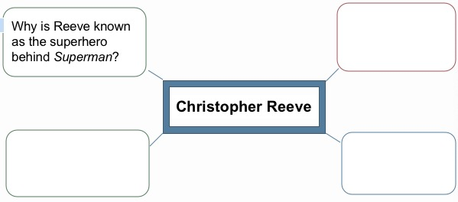

**Task 1: Read the text and underline the answers to these questions.**

1. What was Reeve's“wildly successful Hollywood career”like?
2. How was he injured? Why was it considered a disaster?
3. What did he do after he came out of the“nightmare”?

**Task 2: Read the story and take notes of important facts about Christopher Reeve in the diagram below.**

**Becoming the star in *Superman* films**

1.

2.

**Becoming a superhero in real life**

1.

2.

3.

**Task 3: Summarize Reeve's change of feelings from a superhero in films to a superhero in real life. Give your reasons.**

|  |  |  |
| --- | --- | --- |
| **Occasions** | **Feelings** | **Reasons** |
| **When he succeeded in his Hollywood career** |  |  |
|  | **hopeless, desperate, depressed** |  |
|  |  | **He gained the strength from the ongoing support of his wife, family and friends and from focusing on his goal to walk again.** |
| **During his later years** |  |  |

**Task 4: Think and voice your opinion**

1. What's your understanding of the title “The Superhero Behind Superman”?

2. If you were paralysed and could not follow your dream, what do you think Reeve would say to you?