**学习指南**

**文章梗概**

通过古今交通工具，生活用具，照明方式，等方方面面的对比，体现出现代生活的便捷，安全与舒适。

**阅读任务**

学完文章后，请根据视频中出现的材料，说一说古代与现代的生活方面的不同。

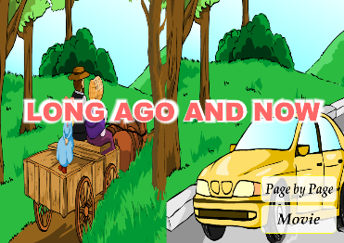**原文**

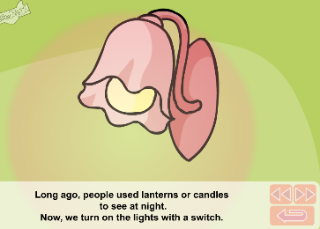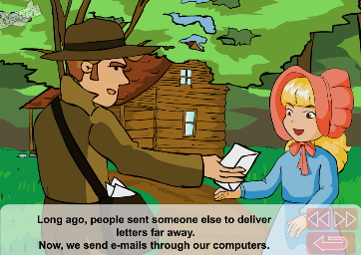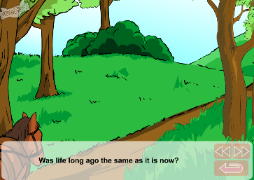

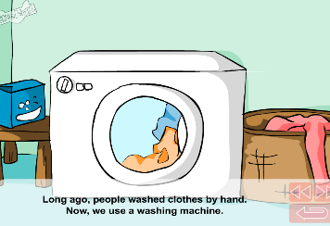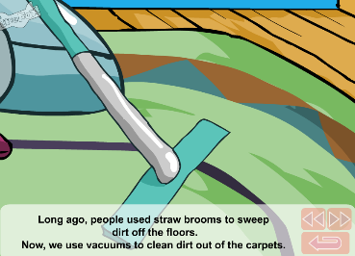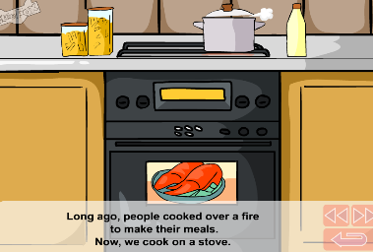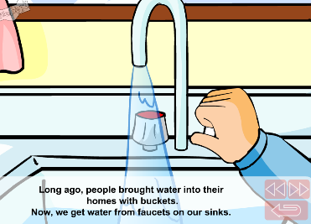

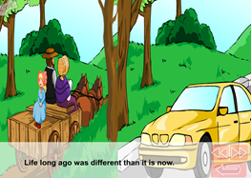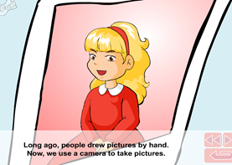

Long ago and now

Was life long ago the same as it is now?

1. Long ago, people sent someone else to deliver letters far away.

Now, we send e-mails through our computer.

2. Long ago, people used lanterns or candles to see at night.

Now, we turn on the lights with a switch.

3. Long ago, people brought water into their homes with buckets.

Now, we get water from faucets on our sinks.

4. Long ago, people cooked over a fire to make their meals.

Now, we cook on a stove.

5. Long ago, people used straw brooms to sweep dirt off the floors.

Now, we use vacuums to clean dirt out of the carpets.

6. Long ago, people washed clothes by hand.

Now, we use a washing machine.

7. Long ago, people drew pictures by hand.

Now, we use a camera to take pictures.

Life long ago was different than it is now.