学习指南
文章梗概
Kipper想要开一个派对，但是没人愿意来。Kipper想到一个好主意，让他的玩具参加派对。Kipper在派对上做了一个“蛋糕”，结果把家里搞的一团糟。最后妈妈很生气，Kipper也感到非常的抱歉。
阅读任务
请你根据Kipper心情变化，来复述这个故事。
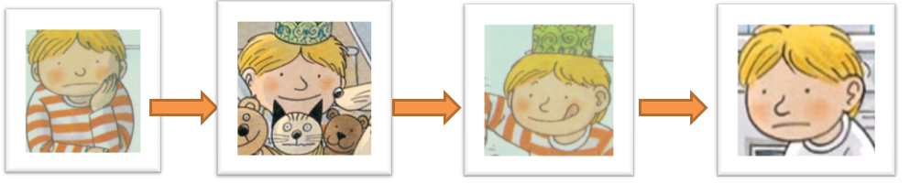
参考答案
1.Kipper wanted a party, but nobody wanted to come. He was sad.
2. He had a party with his toys. He was happy.
3.He made a cake. He put in lots of things.
4. Kipper made the kitchen in a big mess. Mum was cross. Kipper was sorry.
原文
The Toy’s Party
Kipper wanted a party. But nobody wanted to come.
He got his toys. He wanted a cake.
He put in cornflakes. He put in tomato sauce.
He put in milk. He put in jam.
He put in sugar. He put in baked beans.
Mum was cross. Kipper was sorry.

