9年级英语第36课时 学习指南
【学习目标】
本节课结束时，我们能够：
1. 通过听有关“高效完成作业”的文段，整体获取并梳理概括转述的基本策略；
2. 通过听有关“克服羞怯”的文段，实践操练并巩固内化转述的基本策略，提升转述能力；
3. 通过朗读有关“控制愤怒”的文段并对比不同文段录音，关注语言知识（连读、意群划分等），提升朗读能力。

【学习指南】
实战①---听后记录并转述

Advice on how to do homework quickly and easily
Manage time wisely. | - make a 1  - draw up a timetable  - break up a large 2 into smaller ones
Work in a good environment. | - study in a 3 and relaxing area  - turn off your mobile phone and close the door  - sit at a 4 in a comfortable chair
Treat yourself to fun activities. | - go over to a friend’s house  - go out for a 5  - get yourself a sweet treat
转述第一句话已给出：
I’ve got some advice from Chris on how to do homework quickly and easily. We can …

草稿纸

Advice on how to get over shyness
Start with 1 you know. | - start a 2 talk with the one you feel comfortable around  - talk about things you’re interested in  - send out invitations for a party  - try this with new friends
Think of conversation openers. | - 3 yourself  - ask a question  - talk about the 4
Practice before a conversation. | - write down what you want to say and read it out  - just do it  - don’t 5 ; be proud
转述第一句话已给出：
I’ve got some advice from Chris on how to get over shyness. We can …

草稿纸

实战小结①
解题策略：
____________________________________________________
____________________________________________________
____________________________________________________
____________________________________________________
评分标准：
____________________________________________________
____________________________________________________
____________________________________________________
____________________________________________________

实战②---短文朗读
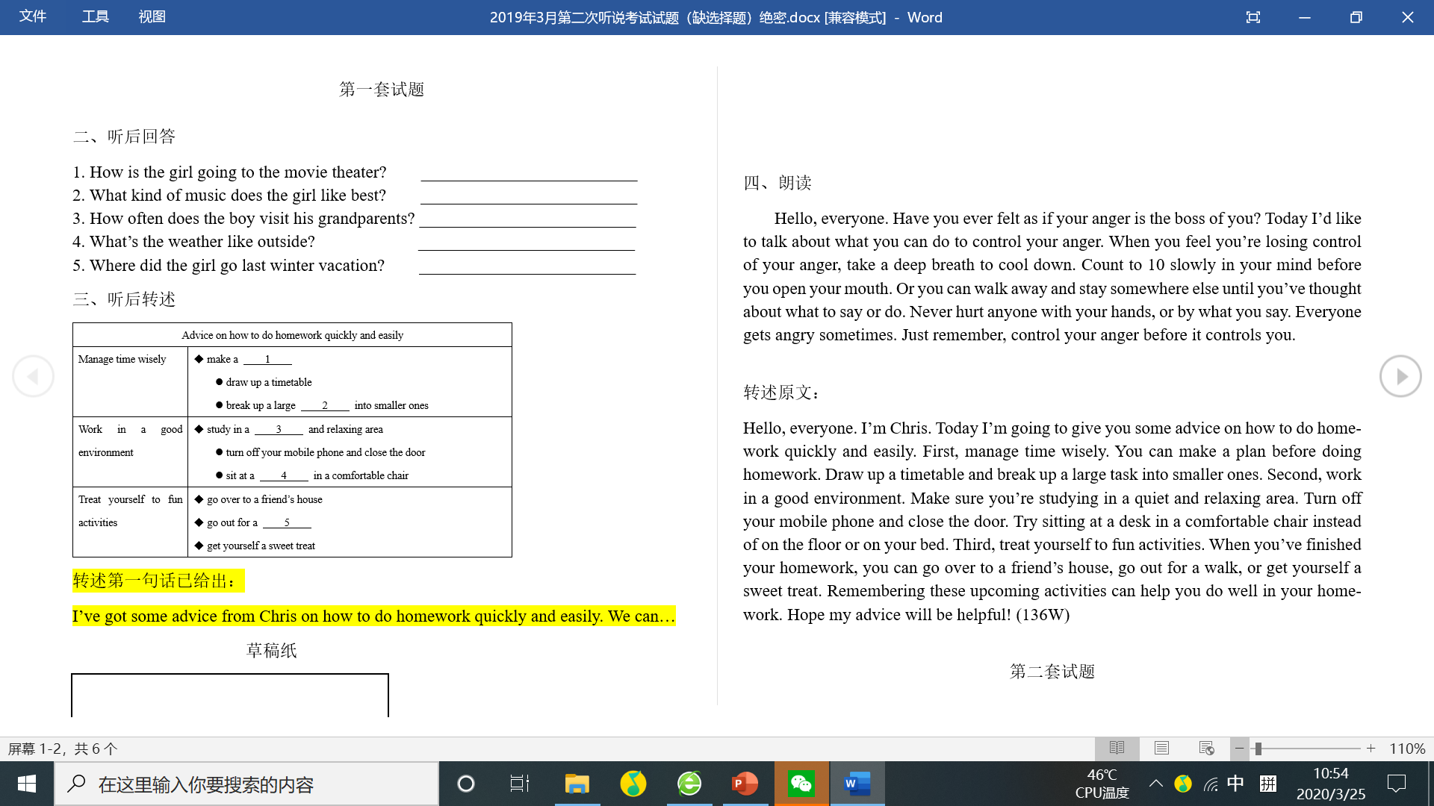

实战小结②
解题策略：
____________________________________________________
____________________________________________________
____________________________________________________
评分标准：
____________________________________________________
____________________________________________________
____________________________________________________

文段材料：
文段1：
Hello, everyone. I’m Chris. Today I’m going to give you some advice on how to do homework quickly and easily. First, manage time wisely. You can make a plan before doing homework. Draw up a timetable and break up a large task into smaller ones. Second, work in a good environment. Make sure you’re studying in a quiet and relaxing area. Turn off your mobile phone and close the door. Try sitting at a desk in a comfortable chair instead of on the floor or on your bed. Third, treat yourself to fun activities. When you’ve finished your homework, you can go over to a friend’s house, go out for a walk, or get yourself a sweet treat.
Remembering these upcoming activities can help you do well in your homework. Hope my advice will be helpful!

文段2：
Hello, everyone. I’m Chris. Today I’m going to give you some advice on how to get over shyness. First, start with people you know. You can start a small talk with the one you feel comfortable around. Talk about things you’re interested in or send out invitations for a party. Then try this with new friends. Second, think of some conversation openers. They make it easier for you to get started. You may introduce yourself, ask a question or talk about the weather. All of these are good conversation openers for you. Third, practice before a conversation. You can write down what you want to say and read it out. Then just do it. Don’t worry if it’s not perfect. Be proud that you gave it a try.
Hope my advice will be helpful!

文段3：
Hello, everyone. Have you ever felt as if your anger is the boss of you? Today I’d like to talk about what you can do to control your anger. When you feel you’re losing control of your anger, take a deep breath to cool down. Count to 10 slowly in your mind before you open your mouth. Or you can walk away and stay somewhere else until you’ve thought about what to say or do. Never hurt anyone with your hands, or by what you say. Everyone gets angry sometimes. Just remember, control your anger before it controls you.

