**8年级英语第32课时**

**《开启健康生活之旅—为你的健康来一份“私人定制”》参考答案**

**任务一: 思考并回答下列问题。**

1. Food and drink, physical activity and sleep.
2. We may have a headache, have a stomachache, catch a cold, sleepy and tired, overweight and hard to sleep.

**任务二: 完成下列健康调查，算一算你得了多少分！**

根据自身情况选择答案。并根据选项分值，累加算出得分。

**任务三: 为以下健康问题选择适当的建议。**

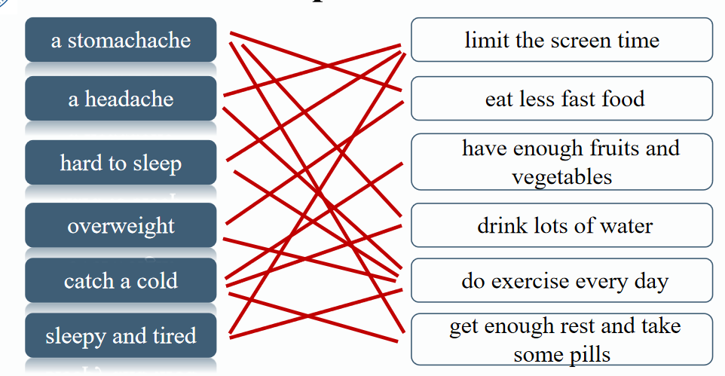

**任务四: 阅读John自述，回答问题。**

1. What’s John’s problem?

He chats with friends at night by We-chat, hasn’t had a good sleep for a while, feels tired and sleepy, always drinks cola, has a cold all the time, and doesn’t get any exercise.

1. Write advice for these problems.
2. It’s not good to chat before you go to bed.
3. You’d better drink water instead of cola.
4. Try to take some exercise. It can make you feel energetic!
5. Read and find out John’s plan.

John is going to

1. turn off his cellphone before 9 pm and read some books to relax.
2. have 45 minutes’ running.
3. have zero sugary drinks.

**任务五: 总结一下如何制定自己的健康计划呢？**

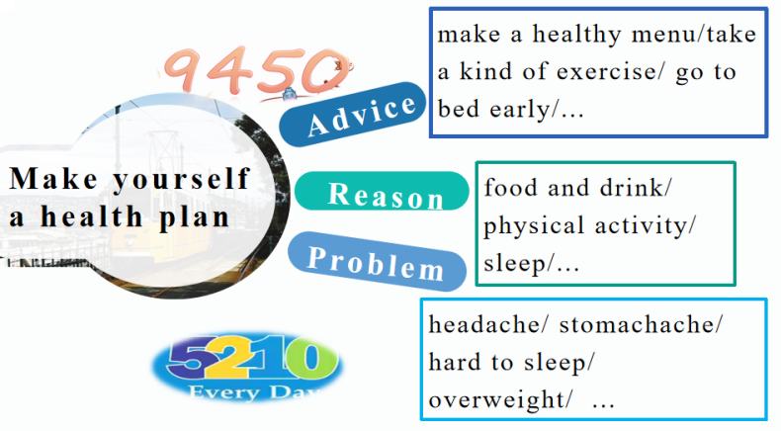

**任务六:写作。**

**Sample 1（范文1）**

I don’t often have health problems. I’d like to be much healthier, so I make myself a health plan.

First, to be healthier, I’m going to have 5 kinds of fruits and vegetables a day. Second, doing exercise has been part of my life. I'm going to keep this habit. Third, too much screen time is harmful to eyes, so I’ll limit my daily screen time to 2 hours. And I’m going to bed early and get enough sleep.

I’m going to keep my plan. And I expect to be healthier and stronger in the future!

**Sample 2 (范文2)**

Since I began to feel tired and sleepy last month, I have thought about my lifestyle and want to make a change.

First, using cellphone has seriously affected my sleep. So I’m going to limit my cellphone time to 20 minutes every night. What’s more, lack of exercise has made me feel tired and sleepy. I am going to jog for 40 minutes every morning. Last but not least, I’m going to make a healthy menu with 6 kinds of fruits and vegetables a day. I call my plan 2046 personal health plan.

I’ll keep doing it. And I expect myself to be healthier and fitter!

**任务七: 巩固练习。**

**一、完成句子。**

1. 锻炼身体已经成为我生活的一部分了。

Doing exercise has become part of my life.

1. 快餐食品对我们的身体有害，我们别吃了。

Fast food is harmful to our health. Let’s stop eating it.

1. 我在电脑游戏方面花费的时间太长了，所以没有时间锻炼身体。

I spend so much time on computer games that I have no time to do exercise.

1. 我已经很长有段时间没有睡好觉了。

I haven’t had a good sleep for a while.

1. 我计划喝无糖饮料以保持健康。

I plan to have zero sugary drinks to keep fit.

**二、阅读短文，根据内容选择最佳选项，将其代号填入提前括号内。**

1. B 2. D 3. C 4. A

**拓展资源参考答案：**

1. A 2. B 3. B