**7年级英语第32课时**

**《听故事学语言》学习指南**

**【学习目标】**

1. 通过词汇学习，视频观看，感悟《Hachi》的故事内涵。
2. 在图片及问答的帮助引导下能够简单讲述这一故事。

**【学习任务】**

**请观看微课，完成下面的任务。**

**任务1：请把下列动词变为过去式。**

walk — _________ like — _________ see — _________

carry — _________ shop — _________ have — _________

**任务2：请你根据图片的情节，预测故事内容并排序。**

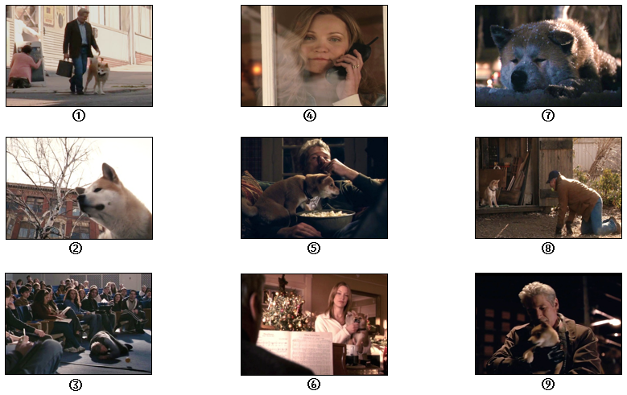

顺序：______________________________________________________________

**任务3：请根据故事回答下列问题。**

1. Where **did** Parker find the puppy? _________________________________________

2. Who **loved** the puppy in the family? _______________________________________

3. What **did** Parker do with Hachi in the yard? _________________________________

4. **Did** his wife change her mind? ___________________________________________

5. What **did** Hachi do with Parker on weekdays? _______________________________

6. What **happened** to Parker in the end? ______________________________________

7.How long **had** Hachi **waited** for his master? _________________________________

**任务4：请在任务1图片和任务2问答的帮助下，描述这一故事。**

Once upon a time ________________________________________________________

__________________________________________________________________________

__________________________________________________________________________

__________________________________________________________________________

**任务5：阅读短文，选择最佳词语完成短文。**

|  |
| --- |
| A. touched B. gained C. left D. followed E. heartwarming |

"A true story of faith, devotion and undying love."

"Hachi: A Dog's Story" is a 1 and inspiring family drama that tells the story of one dog's unwavering loyalty and devotion. When college professor, Parker Wilson(Richard Gere) went off work and discovered an adorable lost Akita puppy wandering around the train station, he took the dog home with him. Hachi 2 Parker to the train station every day and returned to the station every evening to greet his beloved master after work.

On one very sad day, Parker 3 for work and became deathly ill, never to return to the station again. Even after Parker passed away, Hachi faithfully returned to the station everyday for the next nine years, until his death, to wait for his beloved master. During those nine years, this amazing dog touched the lives of the vendors, the stationmaster, and many people at the station square, as taught them the true meaning of loyalty, devotion, and love. Hachi's unyielding devotion and love for his master soon 4 media attention, and this dog's amazing story not only

5 the lives of those at the station square, but all who learned about Hachi's love and devotion.

1. _________ 2. _________ 3. _________ 4. _________ 5. _________