**7年级英语第31课时**

**《英雄回忆录》学习指南**

**【学习目标】**

1. 能够理解及复述中国古代英雄主要事迹的英文表达，正确判断使用一般过去时的句子的表达方式。
2. 能够自主探索一位中国现代英雄的主要事迹，并将其事迹使用第一人称“我”写成一篇短文。

**【学习任务】**

**任务1：你最熟悉的中国古代英雄是谁？请用英文尝试写出一句这个英雄的主要事迹。**

______________________________________________________________________________________

**任务2：观看微课，并完成以下任务。**

1. 请你总结一下，什么时候使用“一般过去时”表达？一般过去时两类句子的肯定句结构分别是什么？

____________________________________________________________________________________

1. 请将下列动词变成“动词过去式”。

visit ___________ lose ___________ start ___________ come ___________

do _____________ tell ___________ die ____________ ask _____________

help ___________ have __________ think __________ win _____________

请你总结微课中提到的动词变成“过去式”的规律：__________________________________________

1. 请根据中国古代英雄所介绍的往事，选择正确答案。

(1) In 202 B.C., I _______ the ruler of China.

A. become B. will become C. became

(2) I _______ Liu Bei win many fights.

A. help B. helped C. am helping

(3) I _______ Zhuge Liang three times and asked him to help me.

A. visited B. visit C. will visit

(4) I _______ my hair and dressed up as a man to join the army.

A. will cut B. am cutting C. cut

(5) I _______ as my mother told me.

A. do B. will do C. did

1. 请记录中国古代英雄介绍往事的英文短语。

____________________________________________________________________________________

**任务3：中国历史的长河中，留下了无数英雄人物的足迹。请你选择一位中国现代英雄人物，查阅他或她**

**的英雄事迹，以“我”的视角，写一篇英文自述“往事回忆录”。以下《感动中国》的英雄人物供参考。**

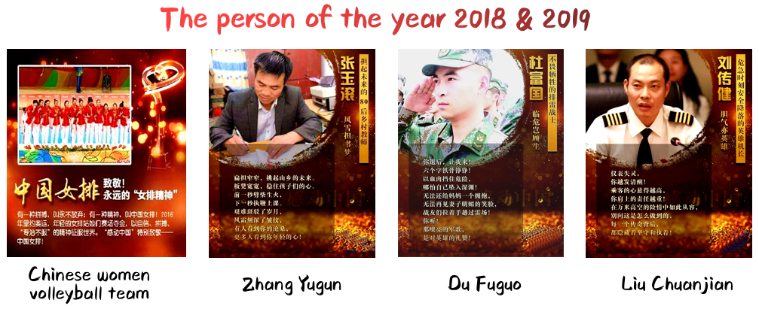

**任务4：巩固练习。用括号所给单词的适当形式填空。**

1. — When were you born?

— I _________ (be) born in 1996.

2. In 2002, I _________ (start) to learn English.

3. Xiang Yu fought (打仗) with Liu Bang, but he _________ (lose) the fight and died at last.

4. At that time, many people _________ (think) that Zhuge Liang was a smart adviser.

5. Yue Fei’s mother _________ (tell) him to be loyal(忠诚的) to the country when he was young.