**9年级英语第33课时 课时作业**

阅读一篇短文，掌握其大意，并应用课上学习的解题方法从短文后各题所给的A、B、C、D四个选项中，选择最佳答案。

**New Technology Revolutionizes(变革) Learning**

More and more people believe that technologies are great for learning. Today, such teaching tools as iPads are used in a lot of courses, including language, history and science.

Many teachers are supporters of using iPads in language learning. They say that students now have much more time for discussion in the classroom. Instead of spending valuable class time listening to texts or watching teaching videos, students can do this on their own and come to class prepared for discussion.

The teachers also say that iPads allow students to learn **at their own pace**. Some students might listen to a dialogue only once and understand it, so they can save time for doing other things. Other students, however, might need to listen to the same dialogue again and again to understand it. Using iPads is especially helpful to students who are learning a language at different paces.

The students who are using the new tool in some courses are also happy. They believe that using iPads is a more enjoyable way to learn (such as listening to stories and watching movies). The class has become much more interesting and creative.

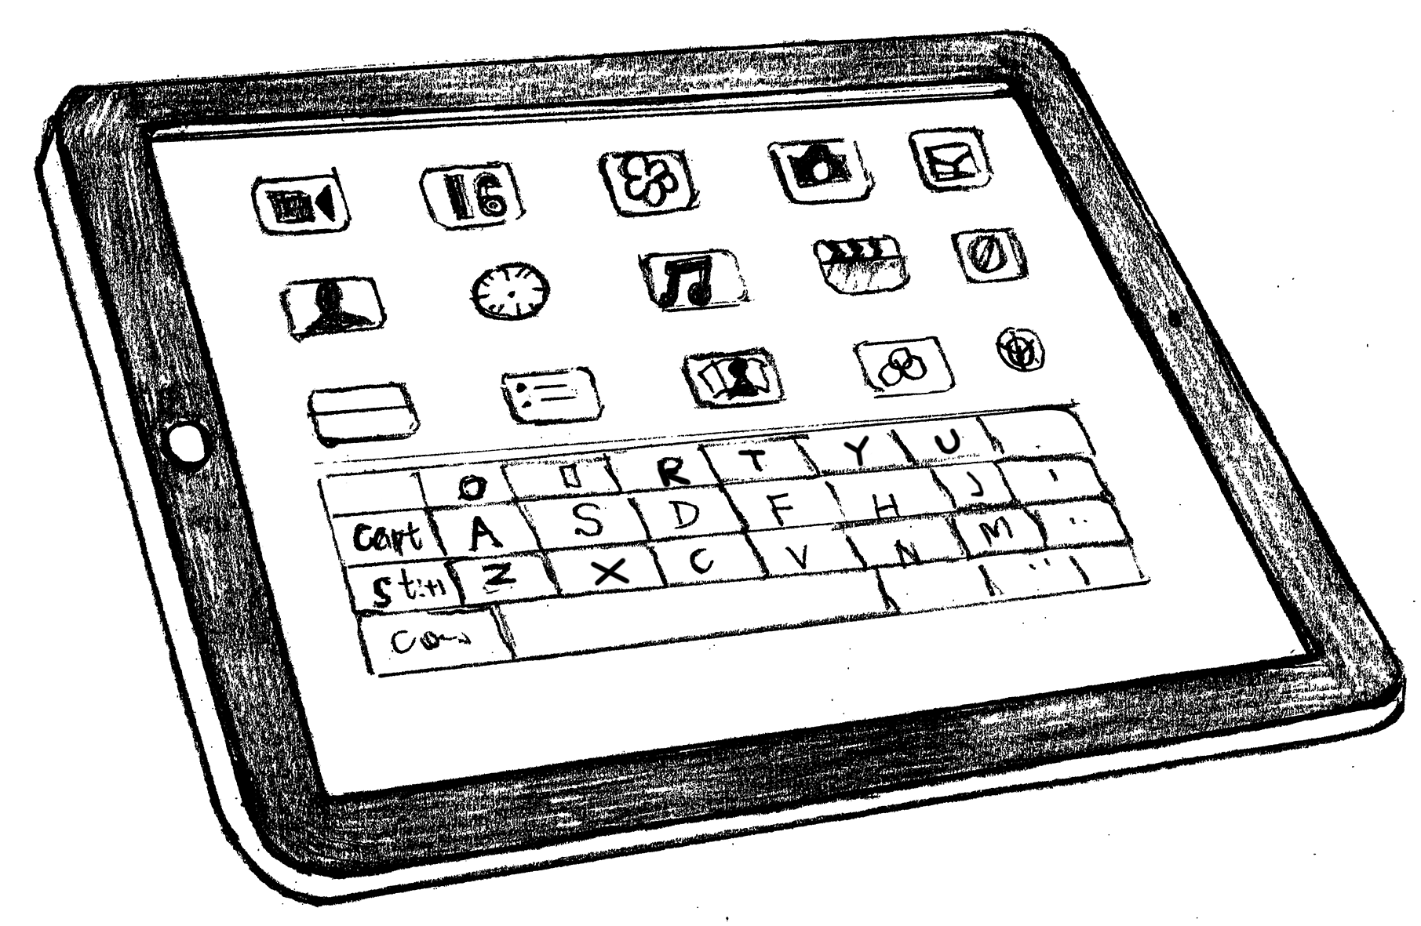 There are other advantages for students. By using iPads, they can pay more attention to the material and learn more. Teaching notes are stored in their iPads and are easy to find. Some students spend more time studying now. “I can listen to my language material or watch teaching videos on the bus, instead of having to wait until I get home,” a student explained.

Many adults complain that technologies such as iPads are doing harm to students. They worry that students might use iPads to download teaching notes and use them to cheat during exams. Some believe that iPads may separate students from each other. If a student spends more time watching videos on an iPad, he will have fewer opportunities to have face-to-face communication with others.

However, technologies are already a part of most students’ day-to-day lives. As for cheating, teachers can ask students to hand in their iPads when they take exams. Education needs to make changes with the times as technology is playing an important part. We should look forward to a wonderful future when iPads and other technologies can add a lot to the classroom.

1．What does the expression “**at their own pace**” in Paragraph 3 probably mean?

A．According to their own timetable. B．Without their teachers’ help.

C．Because of their wonderful goals. D．Against their parents’ hope.

2．From the passage we can learn that ______.

A．students with iPads have less discussion in class

B．students get more fun from learning with iPads

C．iPads help students save time waiting for buses

D．iPads prevent students from cheating in exams

3．The writer probably agrees that ______.

A．teachers can take control of students’ learning

B．exam results depend a lot on new technology

C．technology in education has a bright future

D．note-taking is as helpful as video-watching