**8年级英语第29课时**

**《开启太空之旅—航天英雄面对面》拓展资源**

**中国航天英雄的飞天故事**

**Astronauts return to Earth after 33-day trip**

The return capsule of Shenzhou-11（神州11号太空返回舱）was carrying two Chinese astronauts Jing Haipeng and Chen Dong back to Earth at noon Friday.

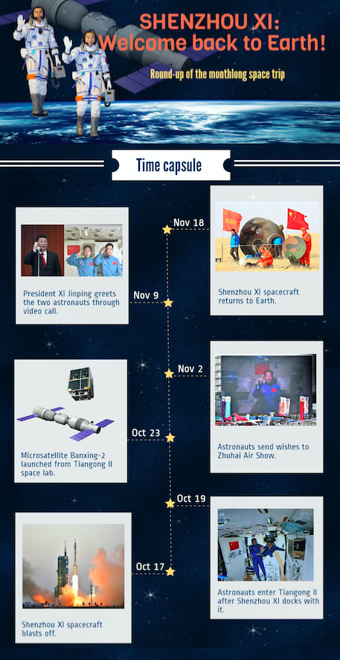The two Chinese astronauts onboard were reporting that they were in good condition. Mission commander Jing Haipeng, 50, and Chen Dong, 37, floated out of the space lab 393 km above Earth and returned to the Shenzhou XI's re-entry capsule on Thursday morning. The Shenzhou XI spacecraft then departed（离开）Tiangong II at 12:41 pm, the China Manned Space Agency said in a statement, adding that the astronauts will arrive back in China on Friday. Jing and Chen embarked on the space trip aboard the Shenzhou XI spacecraft, which departed from the Jiuquan Satellite Launch Center（酒泉卫星发射中心）in Northwest China on Oct 17. They entered Tiangong II, which was launched in mid-September from the same center, on Oct 19.

Their 33-day journey is the longest stay in space by Chinese astronauts. Previously, the longest space trip involving Chinese astronauts was the 15-day Shenzhou X mission in June 2013. Before leaving Tiangong II, they expressed their gratitude and respect for Chinese space workers and those who support the nation's space exploration efforts. China Central Television reported on Thursday that ground workers at the landing site in Siziwang Banner in the Inner Mongolia autonomous 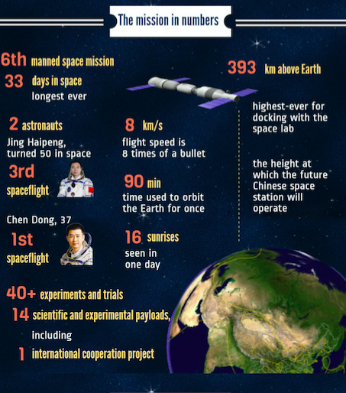region（内蒙古自治区四子王旗）have carried out several drills and are ready to welcome the astronauts.

The Shenzhou XI-Tiangong II mission is China's sixth manned spaceflight and is expected to pave way for a permanent（永久的）space station, which the country plans to start building in 2018 and put into service in about 2022.

Jing is an experienced astronaut, having been a member of the Shenzhou VII mission in 2008 and the Shenzhou IX mission in 2012. He celebrated his 50th birthday during his stay in Tiangong II. Chen is the first man in the second generation of Chinese astronauts to make a spaceflight. Two of his female counterparts in the group, Liu Yang and Wang Yaping, have traveled to space, becoming national heroines.

During the astronauts' stay in the space lab, they worked for eight hours a day, six days a week, completing more than 40 experiments, according to Huang Weifen, deputy research head of the Astronaut Center of China.

As part of their assignments, the astronauts verified the life-support capability of the spacecraft-space lab combination and planted seeds to study the growth of vegetables in space. They used a treadmill and exercise bike in Tiangong II to maintain their physical health, and even conducted a video call with President Xi Jinping on Nov 9.