**8年级第28课时**

**《开启太空之旅—外星生命大猜想》拓展资源**

**这个星球上有水？这个星球上有合适的温度？这个星球上会不会有生命？快去**

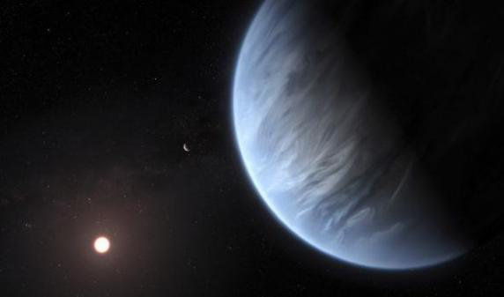**阅读探究吧！请阅读下列短文，根据短文内容，从短文后各题所给的A、B、C、D四个选项中，选择最佳选项。**

**Planet near faraway star has water, temperatures**

**that might support life**

CAPE CANAVERAL, Florida — Scientists have found water at a planet outside our solar system. It even has temperatures that can support life. This is a first.

**"Super Earth" Is Very Far Away**

Two groups of scientists found water vapor (水蒸气) on the surface of a planet very far away. It is 110 light-years away. A light-year is how far light travels in a year. That is billions of miles. Light from our sun reaches earth in about 8 minutes. Stars and galaxies are so far away that their distance is measured in light-years. The planet is in the constellation Leo. Constellations are groups of stars that form patterns (图案) in the sky.

This Super Earth, known as K2-18b, was found in 2015. It is the right distance from its star to support life. It is the only exoplanet we know of with both water and temperatures needed for life. Exoplanets are planets outside our solar system. They orbit or circle around stars.

**Twice The Size Of Earth**

Angelos Tsiaras led one group of scientists. He said the new exoplanet is not a second Earth. Its star and surface (表面) are too different from ours. Tsiaras said conditions similar (相似的) to Earth are not possible.

There was another group of scientists. They said it might even be raining there.

Bjorn Benneke led that study. He said this could help prove (证明) that humans are not alone. He said it was a big step closer to finding life on other planets.

It is twice the size of Earth. Its star is a red dwarf (矮星) that is much smaller and cooler than our sun. Our sun is a yellow dwarf.

**Thousands Of Exoplanets**

K2-18b could help scientists find out if the Earth is ***unique***. Tsiaras said the results are twice as exciting. This is the first Super Earth with water found in its atmosphere. The planet is also within the livable (可生存的) zone (区域) of its star.

This was the first time scientists found water vapor in the surface of another exoplanet.

NASA knows of more than 4,000 exoplanets. NASA is the U.S. space agency. There are another 4,000 possible exoplanets.

**Don't Try To Walk There!**

K2-18b takes 33 days to ***orbit*** its star. So one year there is one month here.

Temperatures can be between very cold or very hot. The surface could be wet or dry. Water vapor can make up (组成) either half of the atmosphere or very little. It would also be hard to walk on the surface because of the planet's size.

1. Read the section **"Super Earth Is Very Far Away".** Which sentence from the section explains why the Super Earth is an important discovery?
2. Stars and galaxies are so far away that their distance is measured in light-years.
3. Constellations are groups of stars that form patterns in the sky.
4. It is the only exoplanet we know of with both water and temperatures needed for life.
5. Exoplanets are planets outside our solar system.
6. Read the section **"Twice The Size Of Earth".** Select the sentence from the section that explains how K2-18b is different from Earth.
7. They said it might even be raining there.
8. He said this could help prove that humans are not alone.
9. He said it was a big step closer to finding life on other planets.
10. Its star is a red dwarf that is much smaller and cooler than our sun.
11. **“K2-18b could help scientists find out if the Earth is unique.”** Which word

could replace **"unique"** WITHOUT changing the meaning of the sentence?

1. Strange. B. New. C. Different. D. Lonely.
2. **“K2-18b takes 33 days to orbit its star. So one year there is one month here.”** What does the word **"orbit"** mean?
3. Go around. B. Push away. C. Speed up. D. Crash into.

同学们，如果还想阅读更多相关资料，也可以点击下面的链接呦！

**Would Mars Be a Good Planet to Live On?**

<https://www.reference.com/science/many-light-years-away-mars-aa2bd9b0c04a3731?qo=contentSimilarQuestions>

# **NASA Now Says Manned Mars Mission in 2030s Is Unlikely**

# <https://www.extremetech.com/extreme/252461-nasa-now-says-manned-mars-mission-2030s-unlikely>