**8年级英语第27课时**

**《开启太空之旅—神秘星球大探索》拓展资源**

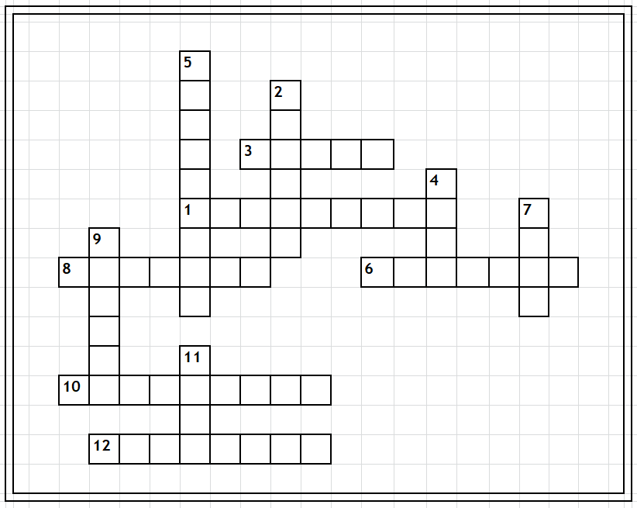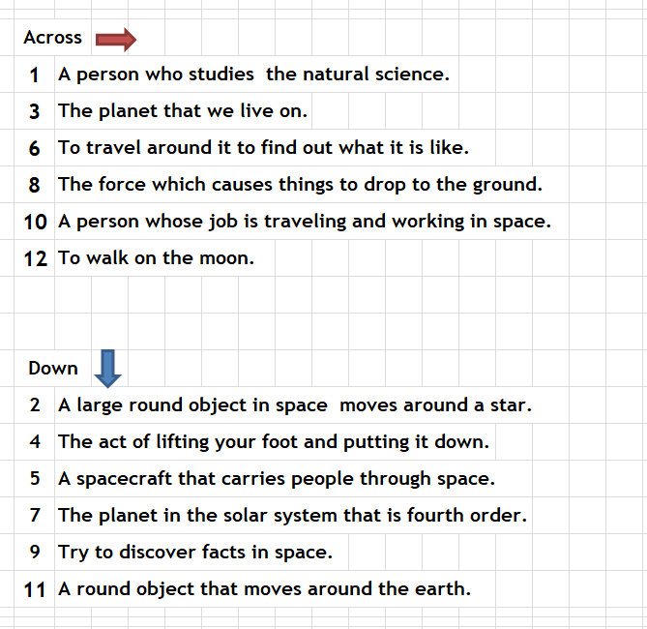**一、Crossword：请根据右栏的提示线索填入本节课中有关太空的12个单词。**

**二、阅读下面拓展材料，根据短文内容，从短文后各题所给的A、B、C、D四个选项中，选择最佳选项。**

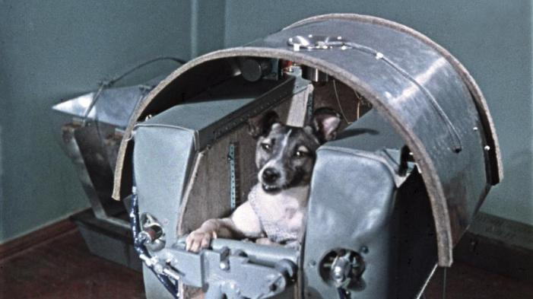 In 1961, the first person blasted off（离地升空）into space. His name was Yuri Gagarin. He circled the earth in his spaceship. This is called orbiting（沿轨道飞行）.

Gagarin was not the first living being to orbit（轨道）. Laika beat him to it. She was a dog! More than three years earlier, Laika made a similar trip. She became the first animal to circle the planet.

Animals like Laika helped humans reach space. They proved astronauts could survive（生存）there. NASA is the U.S. space agency. It says these animals deserve big thanks.

**Animals Flew 62 Miles above Earth**

In 1948, the United States launched a monkey in a rocket. His name was Albert. He flew 39 miles above Earth. The United States also sent up fruit flies. They flew to the edge of space. That is 62 miles above Earth.

The Soviet Union（苏联）was a group of countries. It included Russia. The Soviet space program was very good. Gagarin, the first person to orbit Earth, was a Soviet astronaut.

In 1951, the Soviets launched a rocket. It carried two dogs into space.

**Soviet Dog and American Chimp Orbit Earth**

Laika, though, was the first animal to orbit Earth. She had been a stray dog. Laika circled the planet in 1957. In 1960, the Soviets sent up two more dogs. Their names were Belka and Strelka.

These animal flights were important. They proved humans could go to space. Space travel would not harm them.

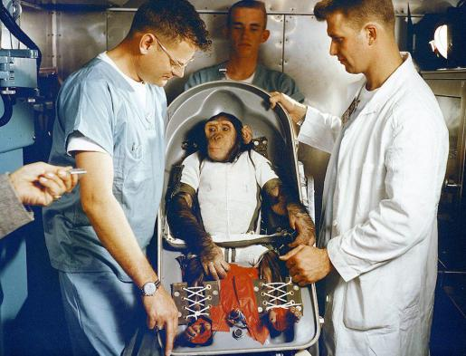In 1961 NASA sent a chimpanzee（黑猩猩）into space. His name was Ham. He cleared the way for astronauts to follow. Soon after, Alan Shepard became the first American in space.

Enos was another NASA test chimp. He orbited Earth in 1962. John Glenn blasted off later that year. He was the first American to reach orbit.

**Animals’ Reaction in space**

Scientists found that different animals have reacted to space travel in different ways. For example, fish and tadpoles(蝌蚪) swam in circles rather than in straight lines.

Honeybees that were taken into space didn’t know what to do at first. However, they did adjust, and they soon built a hive（蜂巢）just like they would have on Earth.

Mice adapted（适应）very quickly when they travelled on a spacecraft. After just a few minutes, they were floating in space behaving almost the same as they would on Earth.

**New Tests for Mars Missions**

Soon, astronauts may fly to Mars. But scientists are not sure it is safe. They are doing tests to make sure. They are using microscopic（微观的）animals. That means they are not visible to human eyes. Humans need microscopes（显微镜）to look at them. These creatures are called "water bears." Tests are being done with mice, too. Animals are still helping humans reach for the stars.

Today, there are very strict rules about taking animals into space. They must be treated with great care, and many people feel that animals should not be used in this way at all. Animals gave scientists the information needed to launch human space travel. Sadly, though, some of them also gave their lives.

1. In the article the first animal to orbit Earth was _________.

A. Gagarin B. Laika C. Albert D. Belka

2. Astronauts hope to safely travel some day on _________.

A. the moon B. Earth's orbit C. Mars D. the Soviet Union

3. Which statement about animals in space is **TRUE** according to the passage?

A. Honeybees in space built a hive at first soon.

B. Fish and tadpoles liked to swim in circles in space.

C. Mice adapted more quickly than honeybees when they were in space.

D. A kind of bear will help humans reach to Mars.

4. What is the article mainly talking about?

A. Dogs from Russia. B. Reactions of animals in space.

C. Animal tests for Mars. D. Space travel by sending animals first.

5. What can we learn from the passage?

A. Animals showing humans that they could safely travel in space.

B. A puppy that was given as a gift to President John F. Kennedy.

C. Two dogs from the Soviet Union that traveled to the moon.

D. Microscopic animals that are being sent on missions to Mars.