8年级英语第27课时
《开启太空之旅—神秘星球大探索》学习指南
【学习目标】
- 能够听懂关于太空探索的新闻简报并获取有关太空探索的具体信息。
- 能够通过阅读有关太空探索的文章，了解探索太空中星球的方式、意义等。
- 能够根据时间线简单介绍人类在太空探索领域所取得的成就。

【学习任务单】
任务一：（请你预习）课前朗读下列短文，并把它译成汉语；课后尝试背诵、默写短文。
Astronauts have already been to the moon but they have not been to any other planets. However, a spaceship has just arrived on Mars and it has already sent back photos of the red planets. Is there life on Mars?We don’t know yet.

任务二：探索神秘星球。请你根据预习文本回答问题。
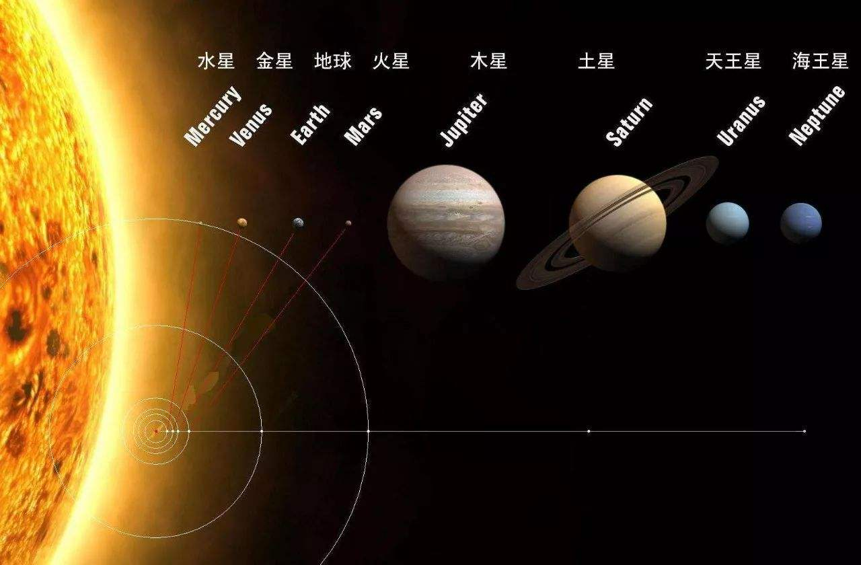
Which planet have we explored? ___________ Where have humans ever been? _____________

任务三：探索星球的方式。请你观看视频和阅读新闻简讯，并选择正确答案或回答问题。
一、Step 1: Unmanned Explores and Probes（无人探测器）
Today, we know much more about space because humans have travelled there.
However, before we sent astronauts or landers to the planets, scientists sent space probes to see if it would be possible. By collecting samples, it did send back valuable information and scientific evidence about outer space.
1. Do people know much more about space today? A. Yes. B. No.
2. Which one did scientists send first? A. Astronauts. B. Landers. C. Probes.
二、Step 2: Animals in Space
If the information, evidence and samples were appropriate（适合的）, in order to know how people would survive travelling there. Scientists would decide to send animals into space to test if they could live without Earth's gravity（重力）and atmosphere（大气层）, and also to test equipment that would later be used for human space flight.
Dogs were the most common animal sent into space. They were good because their size, ways of breathing and blood flow are similar to humans.
Chimpanzees were sent into space because of their similarities to humans and because they could be trained to perform tasks.
Frogs are used to provide information for scientists on how the inner ear works. These flights helped scientists understand motion sickness（运动损伤）.
Monkeys, rats, ants, snails, beetles, fish have also travelled in space.
1. According to the passage, how many kinds of animals have already travelled in space?
A. 8. B. 9. C. 10.
2. What were the most common animal sent into space？
A. Chimpanzees. B. Frogs. C. Dogs.
3. Some parts of __________ are similar to humans.
A. chimpanzees and frogs B. chimpanzees and dogs C. dogs and frogs
4. Make a summary. Why did we choose these kinds of animals?
Dogs | Chimpanzees | Frogs
5. Why did scientists decide to send animals into space?
____________________________________________
三、Step 3: Astronauts in Space
1. Who was the first astronaut into space in the world？ __________________
2. Who was the first astronaut into space in China？ __________________
3. Which country firstly sent astronauts to the moon？ __________________

任务四：探索星球的意义。
一、请你观看视频和阅读短文，并选择正确答案。
Do you know anything about Apollo 11?
July 20th, 1969 was an important day. Two Americans landed on the moon. Their names were Neil Armstrong and Buzz Aldrin. They went there in a spaceship. Its name was Apollo 11.
Apollo 11 left Cape Kennedy on July 16th and went three hundred and eighty-five thousand kilometers. It took the astronauts three days to get there. On July 20th the spaceship landed in the Sea of Tranquility. Armstrong said "That's one small step for a man, one giant leap for mankind" when he first set foot on the lunar surface. Then Armstrong and Aldrin jumped up and down. They felt tired after their moonwalk, so they picked up some rocks and put them in the spaceship. On July 21st, Apollo 11 left the moon and returned to the Earth.

1. Apollo 11 was the name of _______.
A. an American B. a place C. a spaceship
2. People have been to the moon since about_______.
A. 40 years ago B. 50 years ago C. 60 years ago
3. What’s the meaning of Armstrong’s sentence?
A. It was the first time for humans to land on the moon.
B. It was the first time for humans to send a spaceship.
C. Apollo landed on the moon successfully.

二、请你观看视频和阅读新闻报道，并将你所听到的词语填写在空白处。
Do you know anything about the Spirit MER-A?
We've just had some news about the trip to (1) ________. The (2) _________ has reached after a journey of (3) ______ months. It has not sent back any (4) _________ yet. The scientists hope to find (5) _____on Mars. January 2003

三、请你观看视频和阅读短文，并选择正确的选项。
The latest news of Chang’e project
After a series of missions in space for about one month, the Chinese probe, named Change’s 4, launched（发射）on 8th December, 2018, has already successfully touched down on the Moon, unlike Chang’e-3, Chang’e-4 have landed on lunar dark side, where no human or robot has ever reached before. Nearly ten hours later, Chang’e-4 sent its Yutu 2 (“Jade Rabbit 2”) rover into a part of the lunar far side's vast South Pole.
1. When did the Chinese probe touch down on the moon?
A. In January 2019. B. In December 2018. C. In January 2018.
2. The underlined sentence probably means_________________.
A. Chang’e-4 is the first Chinese spaceship landed on the Moon.
B. Chang’e-4 is the first spaceship to land on the far side of the Moon.
C. There is no human or robot where Chang’e-4 has landed.

四、请你在下面的时间轴上中梳理并归纳这三次有意义的星球探索。
Time：
Spaceship：
Meaning：
Days：
Astronauts：
Time：
Spaceship：
Meaning：
Days：
Astronauts：
Time：
Spaceship：
Meaning：
Days：
Astronauts：
1
3
2
Timeline
任务五：新闻播报。
假设你是BBC新闻广播的主播，请你做一期回顾与展望人类太空之旅的节目，依照时间线索，回顾人类探索星球的主要成就及意义。
Hi, everyone! As we know, we’ve already explored…
_____________________________________________________________________
_____________________________________________________________________
_____________________________________________________________________

任务六：课后练习。
一、Word search：请在对应方框中圈出本节课中出现过的有关太空探索的15个英文单词。

二、从下面各题所给的A、B、C、D四个选项中，选出可以填入空白处的最佳选项。
1. Jing Haipeng ______ already ______ to the space three times, nowadays he still works in Beijing.
A. has; gone B. have; been C. has; been D. have; gone
2. Miss Green isn’t in the office. She ______ to the library.
A. has gone B. went C. will go D. has been
3. Apollo 13 is a very nice film. I ______ it many times.
A. will see B. have seen C. saw D. see
4. I have ______ traveled on Mars, but I’m sure someday I will.
A. ever B. already C. never D. just
5. —Have humans arrived at Mars? —No, never. But I ______ about it for a long time.
A. dreams B. will dream C. dream D. have dreamed

