**7年级英语第29课时**

**《童年的纸飞机—回忆过去》拓展资源**

# （一）童年记忆小故事

# 9 Warm Stories From Childhood That Will Melt Your Heart

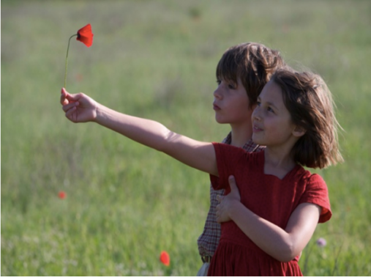Childhood is an unforgettable time full of stories that are both fun and touching.

**▶** Once, a boy from my class approached (靠近) me during naptime in kindergarten. I pretended to be asleep and didn’t move. He lay beside me, kissed me on the cheek, and quietly said, “I love you.” Then he went to his bed. I still remember him going home that day, his gray striped sweatshirt... Now I’m 27, but that childhood confession remains one of the most romantic things I’ve heard in my life.

**▶** When I went to my grandfather’s home outside the town, everyone there had a “Beware of（小心） the dog” sign on their gates. I once got angry with Grandpa for some reason, and while he was at work, I wrote “Beware of Gramps” on his gate.

**▶** A girl once brought a new doll to kindergarten, and it was so pretty even the boys liked it. Everyone played with it, but I was the one to break it. The girl cried, of course, so I decided to give her a similar doll. I asked my parents to buy it for me for my birthday instead of the thing I wanted for myself. They approved, and I gave her that doll on my birthday. The girl’s joy was the best pay-off （回报）I could imagine. And at dinner, my dad gave me my own present as well. He said I did the right thing, and they were proud of me.

**▶** When I was 3, my grandma and I went to the grocery store. There was a line of a few people. One of the women there said to my grandma, “What a beautiful daughter you have!“ Without too much thinking, I pulled down both my shorts and my underpants and said, ”I’m a grandson!“

**▶** When I was 8, I remember our cat giving birth to a litter（一窝幼崽）. After the winter holidays, when I couldn’t get up from bed in the morning, my mom caught all the kittens and let them loose in my bed. They crawled all over me, and I just had to get up to let them down on the floor. One of the warmest memories from my childhood.

**▶** When my brother was little, we lived in a country house, and he often went in the backyard to get suntanned. He took a folding bed, undressed to his shorts, lay down, and covered himself with a blanket. When our mom told him that wasn’t how you tanned, he replied, “If I take it off, mosquitoes will bite me!”

**▶** When I was little, I often played in the sandbox with my friend. She once told me a story about how she’d been digging the sand and had dug so deep she could see the subway and the trains. I believed her and started digging myself, sitting there until late, when my parents took me away. I was so frustrated （沮丧的）when they told me there was no subway in our town!

**▶** Taking a shower as a kid, I liked filling my mouth with water and pretending I was a fountain by spitting it out. I even assumed different “fountain” poses. Some dreamed of becoming doctors, others of flying into space, and I dreamed of becoming a fountain.

**▶** When I was 3, my parents painted the floor. I didn’t notice, and I ran across it, leaving my footprints （脚印） in the paint. Now I’m 21. Recently, when moving the sofa, I saw those same prints. It turned out my parents hadn’t painted them over specifically for me to see them when I grew up.

# 57d415fd5832ad1048bd045486070ee（二）童年记忆歌曲——《英文版稻香》