**7年级英语第27课时**

**《跨文化交际——有趣的肢体语言》学习指南**

**【学习目标】**

1. 能够了解不同国家常见场合使用的一些肢体语言，以及一些常见肢体语言在不同

文化里的不同含义。

2. 能够增强交际中的跨文化意识，从而避免跨文化交际中的文化冲突。

**【学习任务】**

**任务1.** **在现实中，人们除了可以通过文字和语言来交流，还可以通过什么方式交流？**

**_________________________________________________________________________**

**任务2. 观看微课，请把下列图片和相应的文字连接起来。**

Japanese most people in the world Maori people Russian women









kiss on the cheeks touch noses bow to each other shake hands

**任务3. 观看微课，请你写出这些手势在不同文化中的含义。**

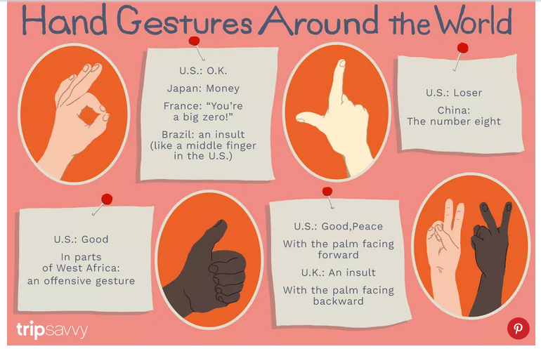

U.S____________________

Japan _________________

Russia _________________

France _________________

Brazil __________________

China __________

U.S ____________



U.S ____________

U.K ____________



1. S ___________________

New Zealand _____________



**任务4.** **阅读短文，选择最佳选项完成短文。**

|  |  |  |  |
| --- | --- | --- | --- |
| Body language is used by people for sending messages to one another. It is very __1__ because it can help you make yourself easily understood. When you are talking with others, you are not just using words, but also using facial expressions and __2__. For example, waving one's hand is to say" Good-bye". Shaking hands means welcome, and clapping hands __3__ congratulations. Nodding the head means agreement, but shaking the head means disagreement. The gestures are __4__ both by the Chinese and most foreigners as having __5__ meanings.      Different countries have different body language. For example, in Russia, France and Arab people kiss each other when they meet, but men in China or Australia shake hands __6__ kissing. People in Puerto Rico like touching each other, but people in Britain do not touch each other. People in Arab like standing __7__ one another when they are talking. __8__, English people always keep a distance __9__  when they are talking.  When you are traveling abroad, it is very important to know the meanings of gestures and movements in the country. __10__ the customs will help you communicate with local people pleasantly and make your stay there enjoyable. | | | |
| (     ) 1. A. helpful         (     ) 2. A. words           (     ) 3. A. to mean         (     ) 4. A. received        (     ) 5. A. good               (     ) 6. A. instead of      (     ) 7. A. nearly          (     ) 8. A. And             (     ) 9. A. from            (     ) 10. A. Taking | B. difficult       B. gestures        B. mean            B. accepted        B. bad              B. stand for       B. far away        B. Or              B. of              B. Refusing | C. easy        C. handshake        C. means            C. receiving        C. different                C. such as          C. close to         C. Because             C. to               C. Following | D. useless          D. idioms           D. meaning          D. accepting        D. the  same            D. compared to      D. side by side     D. However          D. away             D. Saying |