**“令人敬佩的人” A medical pioneer (1) ——学习任务单**

**【学习目标】**

1. **能够概括这篇新闻报道的主要内容;**
2. **能够提新闻报道中关于屠呦呦的细节信息;**
3. **能够使用关键词复述这篇新闻报道。**

**【学法指导】**

**阅读新闻报道时要注意阅读策略：**

1. **略读标题、图片、首段、每段的主题句对文章主要内容有总体概念；**
2. **带着需要查找的某个事实信息的关键词进行有目的地查读。**

**【任务一】Reading for main idea**

Read the text and tick out.

What aspects about Tu Youyou were written in this article?

1. basic personal information

2. appearance and personality

3. attitudes towards fame and future research

4. scientific work

5. the Nobel Prize Award

**【任务二】Reading for details.**

Read again and complete the flow chart.

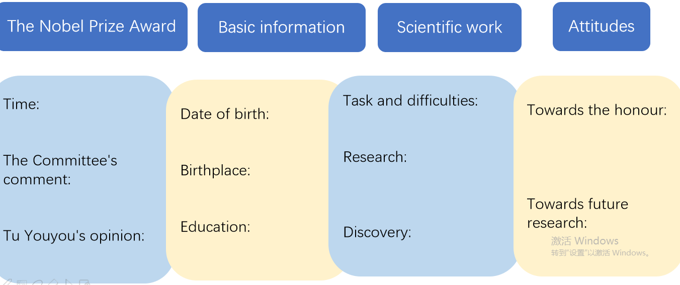

**【任务三】Making a news report based on the flow chart above.**