**学习指南**

**文章梗概**

《HOUSES OF THE WORLD》介绍了全世界不同建筑材料的房子，这些房子的英文名称及所用建筑材料的英文表达。

**阅读任务**

●Task 1 : Please listen, watch and number.

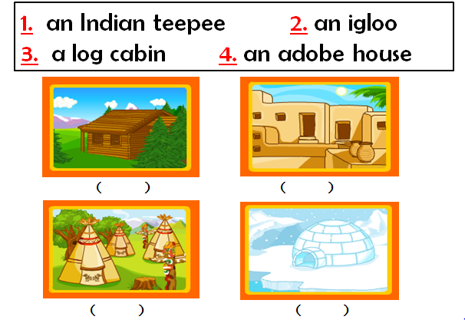

●Task 2 : Please listen, watch and match.

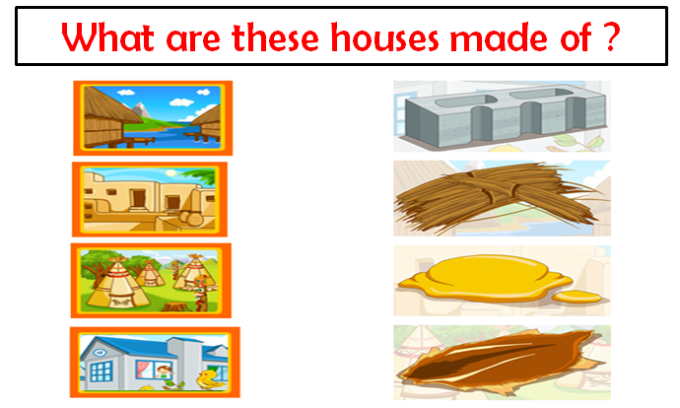

●Task 3: Design “HOUSE IN THE FUTURE”请设计你未来的房子。把它画出来，并用英语告诉大家它的建筑材料是什么，他的特点等等。期待你的设计能在不久的将来实现！

|  |  |
| --- | --- |
| My House in the Future | More about My House |
|  |  |

**原文**

|  |  |
| --- | --- |
|  | |
| **People live in different houses. Their houses are not made the same way.** | **This is a log cabin.**  **It is made of wooden logs.** |
| **This is an old castle.**  **It is made of stones.** | **This is a brick house.**  **It is made of bricks.** |
| **This is a grass hut.**  **It is made of straw.** | **This is an adobe house.**  **It is made of clay.** |
| **This is a tent.**  **It is made of cloth.** | **This is an Indian teepee.**  **It is made of animal skins.** |
| **This is an igloo.**  **It is made of blocks of ice.** | **Where do you live?**  **And how was your house made ?** |
| **I live in an apartment.**  **It is made of concrete blocks.** | |