**9年级英语第29课时 拓展任务**

1. ****了解词源****

[**https://www.etymonline.com**](https://www.etymonline.com)

****如果你对英语词源感兴趣，想一探究竟，这个网站可以满足你的好奇心，帮你答疑解惑。例如，下面是关于单词fair的词源：****

[**fair (adj.)**](https://www.etymonline.com/word/fair#etymonline_v_1083)

Old English *fæger* "pleasing to the sight (of persons and body features, also of objects, places, etc.); beautiful, handsome, attractive," of weather, "bright, clear, pleasant; not rainy," also in late Old English "morally good," from Proto-Germanic *\*fagraz* (source also of Old Saxon *fagar*, Old Norse *fagr*, Swedish *fager*, Old High German *fagar* "beautiful," Gothic *fagrs* "fit"), perhaps from PIE *\*pek-* (1) "to make pretty" (source also of Lithuanian *puošiu* "I decorate").

The meaning in reference to weather preserves the oldest sense "suitable, agreeable" (opposed to **foul** (adj.)). Of the main modern senses of the word, that of "light of complexion or color of hair and eyes, not dusky or sallow" (of persons) is from c. 1200, *faire*, contrasted to *browne* and reflecting tastes in beauty. From early 13c. as "according with propriety; according with justice," hence "equitable, impartial, just, free from bias" (mid-14c.).

Of wind, "not excessive; favorable for a ship's passage," from late 14c. Of handwriting from 1690s. From c. 1300 as "promising good fortune, auspicious." Also from c. 1300 as "above average, considerable, sizable." From 1860 as "comparatively good."

The sporting senses (***fair ball*, *fair catch***, etc.) began to appear in 1856. ***Fair play*** is from 1590s but not originally in sports. ***Fair-haired*** in the figurative sense of "darling, favorite" is from 1909. First record of ***fair-weather friends*** is from 1736 (in a letter from Pope published that year, written in 1730). ***The fair sex*** "women" is from 1660s, from the "beautiful" sense (*fair*as a noun meaning "a woman" is from early 15c.). ***Fair game*** "legitimate target" is from 1776, from hunting.

Others, who have not gone to such a height of audacious wickedness, have yet considered common prostitutes as fair game, which they might pursue without restraint. ["Advice from a Father to a Son, Just Entered into the Army and about to Go Abroad into Action," London, 1776]

1. ****课堂上，我们引用了彭斯的诗歌来了解隐喻概念，现在让我们一起欣赏苏格兰诗人罗伯特彭斯这首著名的诗歌My love Is Like A Red Red Rose. 体会文学作品中的隐喻魅力。****

**罗伯特·彭斯Robert Burns (1759—1796)是苏格兰历史上最伟大的诗人之一 ，是 1 8世纪浪漫主义诗歌的先驱 ，又称苏格兰著名的农民诗人。他一生劳作于田间 ，熟悉古老的苏格兰民谣 ，对诗歌怀有浓厚的兴趣 ，他的诗真实反映了苏格兰农民的思想和渴望 ，具有民主进步思想 ，在形式和内容上具有人民诗歌的特征。彭斯的诗歌抒情泛围广泛 ，即有现实的生活图画 ，热情的浪漫主义情调 ，又有悲剧性色彩。他的诗歌吸取了苏格兰民谣的优点 ，采用苏格兰方言来表现普通劳动人民的思想情感 ，朴实自然、简洁明快 ，具有鲜明的民族特色。**

****下面选用的诗歌是现代英文版本，王作良翻译。****

****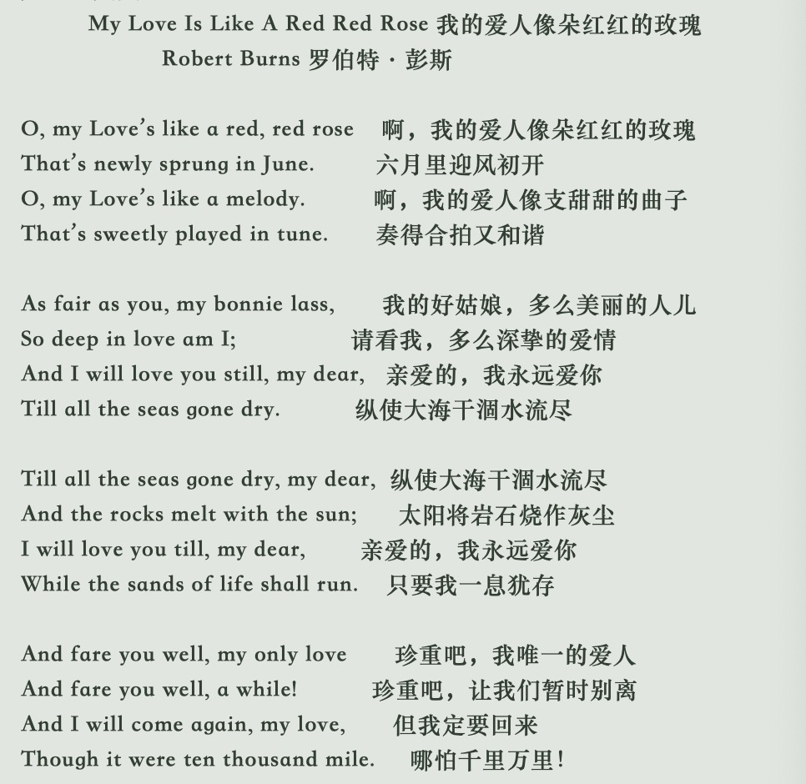****

****这首诗歌的方言版本：****

# A Red，Red Rose

by Robert Burns

O, my Luve's like a red, red rose,

That’s newly sprung in June:

O, my Luve's like the melodie,

That’s sweetly play'd in tune.

As fair art thou, my bonnie lass,

So deep in luve am I,

And I will luve thee still, my dear,

Till a’ the seas gang dry:

Till a’ the seas gang dry, my dear,

And the rocks melt wi’ the sun,

O, I will luve thee still, my dear,

While the sands o’ life shall run.

And fare thee weel, my only Luve!

And fare thee weel a while!

And I will come again, my Luve,

Tho’ it were ten thousand mile！

注释：

1. luve即标准英文中的love，这里是苏格兰方言。

2. sprung是spring的过去式，可作开花讲。

3. melodie =sweet music，甜美的音乐旋律。

4. in tune：harmoniously。

5. fair 美丽；art thou:=are you； bonnie lass= pretty girl。

6. still:=always, forever。

7. until all seas become dry，gang= go。

8. as long as I live，只要我一息尚存。 sand, 指古代计时的沙漏。

9. fare you weel=farewell or say good-bye to somebody。

10. tho’=though，尽管，哪怕之意。